

**A PROJECT**

**Report on**

AUTOMATION TESTING USING SELENIUM WEBDRIVER ON

KESARI TOUR WEBSITE

**BY**

**Komal Mhatre**

**Batch: EON (2020-5220)**

**Under the Guidance of**

**Priyanka Desle**

**Trainer**

**Introduction**

The aim of this project is to do overall testing like Functional Testing on website to check quality of application. It helps to improve quality of website and saves time for manually doing testing. In this project our main focus is to check functionality available on Kesari Tour website. Also it includes title check, Get Text from particular text field, Screenshots and window Scroll down and scroll up .

**Software Requirements**

Operating System : - Windows 10

Browser : - Latest version of Chrome

IDE : - Eclipse IDE

Front End : - Java

**TC01:- Launch the browser and open Kasari tour website**

System.*setProperty*("webdriver.gecko.driver","C:\\Users\\Admin\\Desktop\\selenium-java-3.141.59\\geckodriver.exe");

WebDriver w = **new** FirefoxDriver();

w.get("https://www.kesari.in/");

// successfully launch the browser and opened kesari tour website

**TC02:- To check the Maximise size and get URL of Kesari Tour Website page.**

w.get("https://www.kesari.in/");

w.manage().window().maximize();

System.***out***.println(w.getCurrentUrl());

Thread.*sleep*(2000);

System.***out***.println(w.getTitle());

**TC 03:- To check the functionality of next page (Notice of Traveller )**

w.findElement(By.*xpath*("/html[1]/body[1]/div[6]/div[1]/div[1]/div[1]/div[1]/button[1]")).click();

**TC04:- Take Screenshot of Welcome Page**

w.findElement(By.*xpath*("//body/div[3]/div[2]/div[1]/div[1]/a[1]/img[1]")).click();

Thread.*sleep*(5000);

TakesScreenshot t =(TakesScreenshot) w;

File src = t.getScreenshotAs(OutputType.***FILE***);

Files.*copy*(src, **new** File ("D:\\HI\\SS.png"));

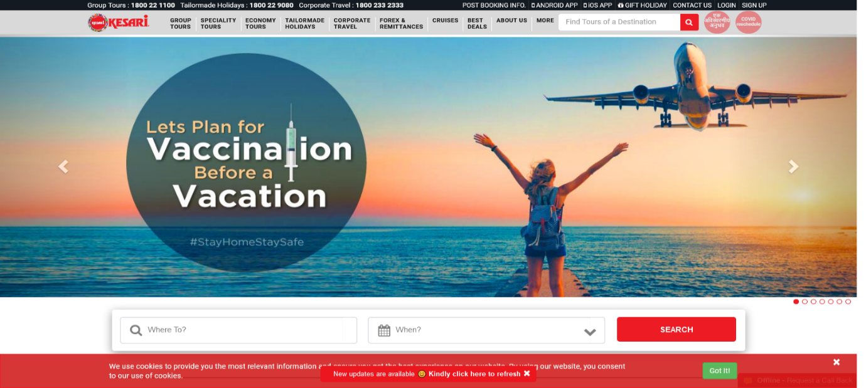

**TC05:- To Check Functionality of SIGN UP Module**

//SIGN UP PAGE

Thread.*sleep*(2000);

w.findElement(By.*cssSelector*("div.ng-scope:nth-child(2) header.navbar-static-top.ng-scope:nth-child(2) div.topnav.custom-topnav.hidden-xs.hidden-sm div.topnav__top div.container div.row div.col-lg-6.col-md-8:nth-child(2) ul.quick-menu.pull-right.list-unstyled.mb-0 li:nth-child(8) > a:nth-child(1)")).click();

Thread.*sleep*(5000);

**TC06:- To Check Valid First Name Faction of Signup Sub Module**

//Name

w.findElement(By.*id*("firstname")).sendKeys("Shraddha");

**TC07:- To Check Valid Last Name Faction of Signup Sub Module**

//Lastname

w.findElement(By.*id*("lastname")).sendKeys("Sakat");

**TC08:- To Check Valid Email Id Faction of Signup Sub Module**

//Emailid

w.findElement(By.*name*("email")).sendKeys("sss123@gmail.com");

**TC09:- To Check Valid Password Faction of Signup Sub Module**

//Password

w.findElement(By.*name*("password")).sendKeys("Sss@123ss ");

**TC010:- To Check Valid Confirm Password Faction of Signup Sub Module**

//Confirm password

w.findElement(By.*name*("password_c")).sendKeys("Sss@123ss ");

**TC11:- To Check Gender Faction of Signup Sub Module**

//Drop Down for gender

w.findElement(By.*name*("gender")).click();

Select s=**new** Select(w.findElement(By.*name*("gender")));

s.selectByIndex(2);

**TC12:- To Check Date Faction of Signup Sub Module**

// Signup

w.findElement(By.*xpath*("//body/div[3]/section[1]/div[1]/div[1]/div[2]/div[1]/form[1]/div[6]/div[1]/input[1]")).click();

w.findElement(By.*xpath*("//tbody/tr[6]/td[6]/button[1]/span[1]")).click();

**TC13:- To Check Valid Mobile Faction of Signup Sub Module**

//Mobile number

w.findElement(By.*name*("mobile")).sendKeys("7780055308");

**TC14:- To Check Remember-Checkbox Faction of Signup Sub Module**

w.findElement(By.*id*("remember-checkbox")).click();

**TC15:- To check the Functionality of SIGN UP button**

w.findElement(By.*xpath*("/html[1]/body[1]/div[3]/section[1]/div[1]/div[1]/div[2]/div[1]/form[1]/div[9]/div[1]/div[1]/button[1]")).click();

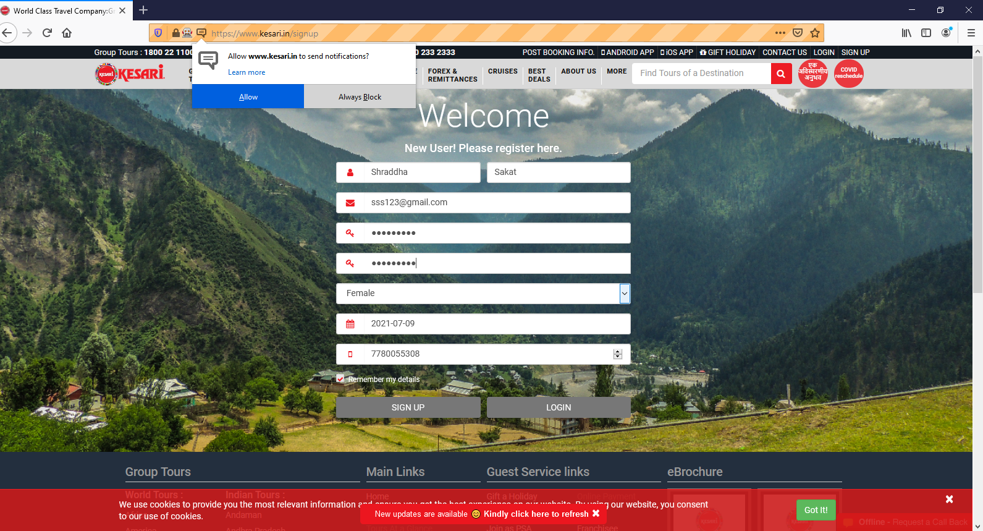

//successfully signup the page

**TC 16:- To check the Functionality of LOGIN Module**

//LOGIN PAGE

Thread.*sleep*(5000);

w.findElement(By.*cssSelector*("div.ng-scope:nth-child(2) header.navbar-static-top.ng-scope:nth-child(2) div.topnav.custom-topnav.hidden-xs.hidden-sm div.topnav__top div.container div.row div.col-lg-6.col-md-8:nth-child(2) ul.quick-menu.pull-right.list-unstyled.mb-0 li:nth-child(7) > a:nth-child(1)")).click();

//successfully login module opened

**TC17:- To Check Valid Email Id Faction of Login Sub Module**

//Emailid

w.findElement(By.*name*("email")).sendKeys("sss123@gmail.com");

**TC18:- To Check Valid Password Faction of Login Sub Module**

//Password

w.findElement(By.*name*("password")).sendKeys("Sss@123ss");

**TC19:- To Check Login to your Account button Faction of Login Sub Module**

w.findElement(By.*xpath*("//button[contains(text(),'Login to Your Account')]")).click();

**TC20:- To Check Forgotten Password button Faction of Login Sub Module**

//forgotton password

w.findElement(By.*linkText*("Forgotten Password?")).click();

**TC21:- To Check Signup for Kesari button Faction of Login Sub Module**

w.findElement(By.*linkText*("Signup for Kesari")).click();

Thread.*sleep*(5000);

TakesScreenshot t2=(TakesScreenshot) w;

File src2 =t2.getScreenshotAs(OutputType.***FILE***);

Files.*copy*(src2, **new** File("D:\\HI\\login.png"));

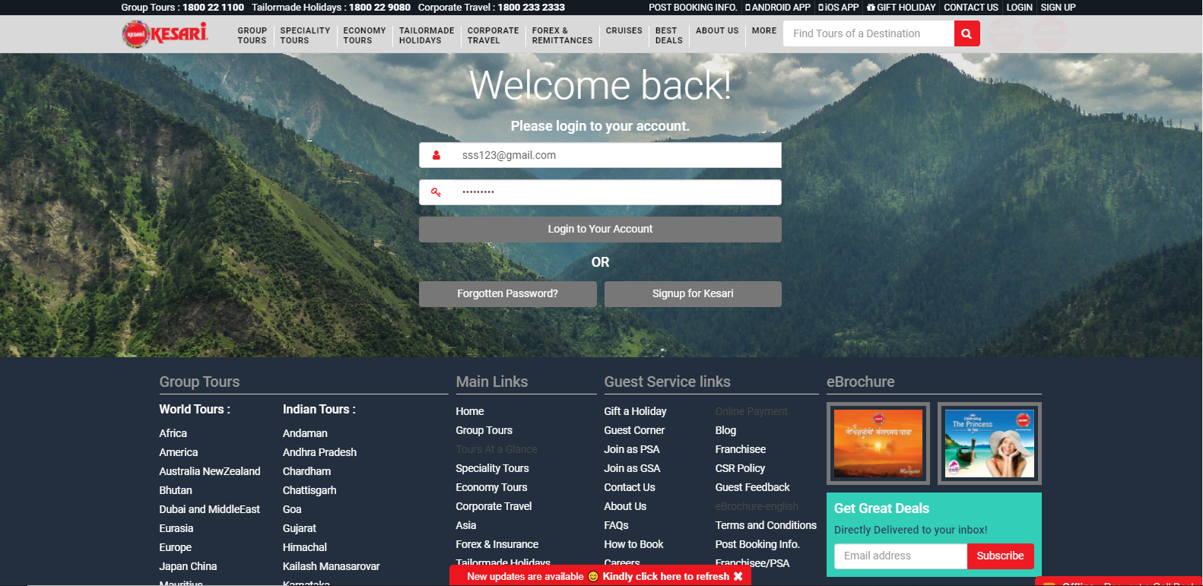

**TC 22:- To check the Functionality of Next Function**

// Next function

w.findElement(By.*cssSelector*("body.modal-open:nth-child(2) div.modal.in:nth-child(6) div.modal-dialog.modal-lg div.modal-content div.card-spin div.card-header > button.close.close-spin")).click();

**TC 23:- To check the Functionality of Contact Module**

// contact module

w.findElement(By.*cssSelector*("div.ng-scope:nth-child(2) header.navbar-static-top.ng-scope:nth-child(2) div.topnav.custom-topnav.hidden-xs.hidden-sm div.topnav__top div.container div.row div.col-lg-6.col-md-8:nth-child(2) ul.quick-menu.pull-right.list-unstyled.mb-0 li:nth-child(5) > a:nth-child(1)")).click();

TakesScreenshot t3=(TakesScreenshot) w;

File src3 =t3.getScreenshotAs(OutputType.***FILE***);

Files.*copy*(src3, **new** File("D:\\HI\\contact.png"));

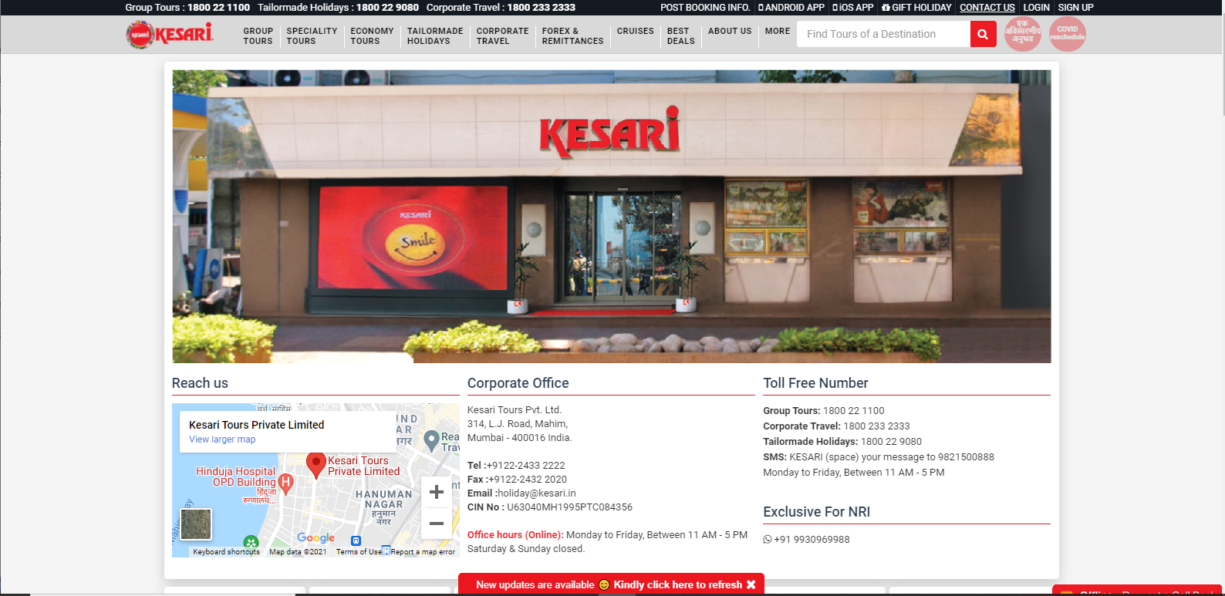

**TC 24:- To check the Functionality of Gift Holiday module**

//GIFT HOLIDAY

w.findElement(By.*cssSelector*("div.ng-scope:nth-child(2) header.navbar-static-top.ng-scope:nth-child(2) div.topnav.custom-topnav.hidden-xs.hidden-sm div.topnav__top div.container div.row div.col-lg-6.col-md-8:nth-child(2) ul.quick-menu.pull-right.list-unstyled.mb-0 li:nth-child(4) > a:nth-child(1)")).click();

**TC25:- To Check Signup for Kesari button Faction of Login Sub Module**

//FROM

Thread.*sleep*(5000);

w.findElement(By.*name*("name")).sendKeys("ShraddhaS");

w.findElement(By.*name*("email")).sendKeys("sss@gmail.com");

w.findElement(By.*name*("tel")).sendKeys("7878955378"); //Phone number

w.findElement(By.*name*("amount")).sendKeys("11000"); //Amount

w.findElement(By.*name*("address")).sendKeys("Pune");

//TO

w.findElement(By.*name*("Toname")).sendKeys("DivyaD");

w.findElement(By.*name*("Toemail")).sendKeys("ddd@gmail.com");

w.findElement(By.*name*("Totel")).sendKeys("9678776655");

w.findElement(By.*name*("message")).sendKeys("Take Care");

w.findElement(By.*xpath*("//button[contains(text(),'Submit')]")).submit();

w.navigate();

|  |
| --- |
| **TC26:- To check the Functionality of IOS App Module** |

// IOS App

w.findElement(By.*xpath*("//*[@id=\"header\"]/div[1]/div[1]/div/div/div[2]/ul/li[3]/a")).click();

Set <String> Windows=w.getWindowHandles();

Iterator <String> it=Windows.iterator();

String parent_window=it.next();

String child_window=it.next();

w.switchTo().window(child_window);

Thread.*sleep*(2000);

w.switchTo().window(parent_window);

Thread.*sleep*(2000);

System.***out***.println("Reach to parent window ");

Thread.*sleep*(5000);

|  |
| --- |
| **TC27- To check the Functionality of ANDROID APP Modula** |

//ANDROID APP

w.findElement(By.*xpath*("//*[@id=\"header\"]/div[1]/div[1]/div/div/div[2]/ul/li[2]/a")).click();

System.***out***.println("Reach to ANDROID APP web page ");

Set <String> Windows1=w.getWindowHandles();

Iterator <String> it1=Windows1.iterator();

String parent_window1=it1.next();

String child_window1=it1.next();

w.switchTo().window(child_window1);

Thread.*sleep*(2000);

w.switchTo().window(parent_window1);

Thread.*sleep*(2000);

System.***out***.println("Reach to parent window ");

Thread.*sleep*(5000);

System.***out***.println("Back to home Page");

Thread.*sleep*(5000);

|  |
| --- |
| **TC28:- To check the Functionality of POST BOOKING INFO Module** |

//POST BOOKING INFO

w.findElement(By.*xpath*("//*[@id=\"header\"]/div[1]/div[1]/div/div/div[2]/ul/li[2]/a")).click();

Set <String> Windows2=w.getWindowHandles();

Iterator <String> it2=Windows2.iterator();

String parent_window2=it2.next();

String child_window2=it2.next();

w.switchTo().window(child_window2);

Thread.*sleep*(3000);

w.switchTo().window(parent_window2);

Thread.*sleep*(2000);

System.***out***.println("Back to Home page from Post Booking Info ");

Thread.*sleep*(5000);

|  |
| --- |
| **TC29:- To check the Functionality of More Module** |

Actions a=**new** Actions(w);

a.moveToElement(w.findElement(By.*cssSelector*("div.ng-scope:nth-child(2) header.navbar-static-top.ng-scope:nth-child(2) div.topnav.custom-topnav.hidden-xs.hidden-sm div.container nav.hidden-xs.hidden-sm ul.menu.list-unstyled.mb-0 li.menu-item-has-children:nth-child(10) > a:nth-child(1)"))).perform();

|  |
| --- |
| **TC 30:- To check the Functionality of Guest Corner submodule** |

w.findElement(By.*cssSelector*("div.ng-scope:nth-child(2) header.navbar-static-top.ng-scope:nth-child(2) div.topnav.custom-topnav.hidden-xs.hidden-sm div.container nav.hidden-xs.hidden-sm ul.menu.list-unstyled.mb-0 li.menu-item-has-children:nth-child(10) ul.singlemenu.left.list-unstyled.mb-0:nth-child(2) li:nth-child(1) > a:nth-child(1)")).click();

Thread.*sleep*(5000);

w.findElement(By.*cssSelector*("div.ng-scope:nth-child(3) section.ng-scope:nth-child(2) div.container div.row div.col-xs-12 div.tab-container.nav-tabs-custom div.ng-isolate-scope:nth-child(3) ul.nav.nav-tabs li.tab-pane.ng-isolate-scope.active:nth-child(1) > a.ng-binding")).click();

System.***out***.println("Successfully Check Guest Corner");

|  |
| --- |
| **TC31:- To check the Functionality of Kesari Academy** |

//Kesari Acadami

w.findElement(By.*cssSelector*("div.ng-scope:nth-child(2) header.navbar-static-top.ng-scope:nth-child(2) div.topnav.custom-topnav.hidden-xs.hidden-sm div.container nav.hidden-xs.hidden-sm ul.menu.list-unstyled.mb-0 li.menu-item-has-children:nth-child(10) ul.singlemenu.left.list-unstyled.mb-0:nth-child(2) li:nth-child(2) > a:nth-child(1)")).click();

//Register

w.findElement(By.*xpath*("/html[1]/body[1]/div[3]/section[1]/div[1]/div[1]/div[1]/div[1]/div[1]/div[1]/button[1]")).click();

//Name

w.findElement(By.*xpath*("/html[1]/body[1]/div[9]/div[1]/div[1]/div[1]/form[1]/div[1]/div[1]/div[1]/div[1]/input[1]")).sendKeys("Ganga");;

w.findElement(By.*cssSelector*("#exampleInputEmail1")).sendKeys("Rohit");

w.findElement(By.*xpath*("/html[1]/body[1]/div[9]/div[1]/div[1]/div[1]/form[1]/div[1]/div[1]/div[3]/div[1]/input[1]")).sendKeys("Sharma");

w.findElement(By.*xpath*("/html[1]/body[1]/div[9]/div[1]/div[1]/div[1]/form[1]/div[1]/div[2]/div[1]/div[1]/input[1]")).sendKeys("22");

w.findElement(By.*xpath*("/html[1]/body[1]/div[9]/div[1]/div[1]/div[1]/form[1]/div[1]/div[2]/div[2]/div[1]/input[1]")).sendKeys("7877986479");

w.findElement(By.*xpath*("/html[1]/body[1]/div[9]/div[1]/div[1]/div[1]/form[1]/div[1]/div[2]/div[1]/div[1]/input[1]")).sendKeys("grs@gamil.com");

w.findElement(By.*xpath*("/html[1]/body[1]/div[9]/div[1]/div[1]/div[1]/form[1]/div[1]/div[3]/div[1]/div[1]/input[1]")).sendKeys("Pune");

w.findElement(By.*xpath*("/html[1]/body[1]/div[9]/div[1]/div[1]/div[1]/form[1]/div[1]/div[3]/div[2]/div[1]/input[1]")).sendKeys("458027");

w.findElement(By.*xpath*("/html[1]/body[1]/div[9]/div[1]/div[1]/div[1]/form[1]/div[1]/div[3]/div[3]/div[1]/select[1]")).click();

Select s1=**new** Select(w.findElement(By.*cssSelector*("body.modal-open:nth-child(2) div.modal.ng-isolate-scope.in:nth-child(20) div.modal-dialog.modal-lg div.modal-content div.ng-scope form.ng-invalid.ng-invalid-required.ng-valid-pattern.ng-dirty.ng-valid-number div.modal-body div.row:nth-child(4) div.col-sm-4.col-xs-6.col-xss-12:nth-child(3) div.form-group > select.form-control.ng-pristine.ng-invalid.ng-invalid-required.ng-touched:nth-child(2)")));

s1.selectByIndex(2);

//submit

w.findElement(By.*cssSelector*("body.modal-open:nth-child(2) div.modal.ng-isolate-scope.in:nth-child(20) div.modal-dialog.modal-lg div.modal-content div.ng-scope form.ng-invalid.ng-invalid-required.ng-valid-pattern.ng-dirty.ng-valid-number div.modal-footer > button.btn.btn-primary:nth-child(1)")).submit();

Thread.*sleep*(2000);

|  |
| --- |
| **TC32:- To check the Functionality of Tours at a Glance** |

//Tours at a glance

w.findElement(By.*cssSelector*("div.ng-scope:nth-child(2) header.navbar-static-top.ng-scope:nth-child(2) div.topnav.custom-topnav.hidden-xs.hidden-sm div.container nav.hidden-xs.hidden-sm ul.menu.list-unstyled.mb-0 li.menu-item-has-children:nth-child(10) ul.singlemenu.left.list-unstyled.mb-0:nth-child(2) li:nth-child(3) > a:nth-child(1)")).click();

w.findElement(By.*cssSelector*("div.ng-scope:nth-child(3) section.ng-scope:nth-child(2) div.container div.tab-container.nav-tabs-custom ul.nav.nav-tabs li.active:nth-child(1) > a:nth-child(1)")).click();

Thread.*sleep*(2000);

w.findElement(By.*cssSelector*("div.ng-scope:nth-child(3) section.ng-scope:nth-child(2) div.container div.tab-container.nav-tabs-custom ul.nav.nav-tabs li.active:nth-child(2) > a:nth-child(1)")).click();

Thread.*sleep*(5000);

|  |
| --- |
| **TC33:-To check the Functionality of Marathi Test Module** |

w.findElement(By.*cssSelector*("div.ng-scope:nth-child(2) header.navbar-static-top.ng-scope:nth-child(2) div.topnav.custom-topnav.hidden-xs.hidden-sm div.container nav.hidden-xs.hidden-sm ul.menu.list-unstyled.mb-0 li.menu-item-has-children:nth-child(10) ul.singlemenu.left.list-unstyled.mb-0:nth-child(2) li:nth-child(4) > a:nth-child(1)")).click();

|  |
| --- |
| **TC34:-To check the Functionality of FAQ Module** |

w.findElement(By.*cssSelector*("div.ng-scope:nth-child(2) header.navbar-static-top.ng-scope:nth-child(2) div.topnav.custom-topnav.hidden-xs.hidden-sm div.container nav.hidden-xs.hidden-sm ul.menu.list-unstyled.mb-0 li.menu-item-has-children:nth-child(10) ul.singlemenu.left.list-unstyled.mb-0:nth-child(2) li:nth-child(5) > a:nth-child(1)")).click();

w.findElement(By.*linkText*("Group Tours")).click();

w.findElement(By.*linkText*("Tailormade Tours")).click();

|  |
| --- |
| **TC35:-To Check the Functionality of How to Book** |

//How To BOOk

w.findElement(By.*cssSelector*("div.ng-scope:nth-child(2) header.navbar-static-top.ng-scope:nth-child(2) div.topnav.custom-topnav.hidden-xs.hidden-sm div.container nav.hidden-xs.hidden-sm ul.menu.list-unstyled.mb-0 li.menu-item-has-children:nth-child(10) ul.singlemenu.left.list-unstyled.mb-0:nth-child(2) li:nth-child(6) > a:nth-child(1)")).click();

|  |
| --- |
| **TC36 :- To check the functionality of Group Tour button and click on Group Tour button**. |

Actions a=**new** Actions(w);

WebElement wb=w.findElement(By.*cssSelector*("div.ng-scope:nth-child(2) header.navbar-static-top.ng-scope:nth-child(2) div.topnav.custom-topnav.hidden-xs.hidden-sm div.container nav.hidden-xs.hidden-sm ul.menu.list-unstyled.mb-0 li.menu-item-has-children.megamenu-menu.group-tour-menu:nth-child(1) > a:nth-child(1)"));

a.moveToElement(wb).click().build().perform();

//Group tour package is open

|  |
| --- |
| **TC37 :- To check the functionality of Dubai and MIddleEast button By clicking on Dubai and MiddleEast Button.** |

w.findElement(By.*linkText*("Dubai and MiddleEast")).click();

//Dubai and MiddleEast Package open successfully.

|  |
| --- |
| **TC38 :- To check the functionality of Enquiry button By clicking on Enquiry button.** |

w.findElement(By.*linkText*("Dubai and MiddleEast")).click();

//Dubai with theme parks premium Enquiry page open successfully.

|  |
| --- |
| **TC39 :- To check the functionality of Submit button by entering valid data and clicking on submit button.** |

w.findElement(By.*xpath*("//body/div[9]/div[1]/div[1]/div[1]/div[2]/form[1]/div[1]/div[1]/input[1]")).sendKeys("prachi patil");

w.findElement(By.*xpath*("//body/div[9]/div[1]/div[1]/div[1]/div[2]/form[1]/div[2]/div[1]/input[1]")).sendKeys("pen");

w.findElement(By.*xpath*("//body/div[9]/div[1]/div[1]/div[1]/div[2]/form[1]/div[3]/div[1]/input[1]")).sendKeys("19");

w.findElement(By.*xpath*("//body/div[9]/div[1]/div[1]/div[1]/div[2]/form[1]/div[4]/div[1]/input[1]")).sendKeys("prachi123@gmail.com");

w.findElement(By.*xpath*("//body/div[9]/div[1]/div[1]/div[1]/div[2]/form[1]/div[5]/div[1]/input[1]")).sendKeys("8765432198");

w.findElement(By.*xpath*("//body/div[9]/div[1]/div[1]/div[1]/div[2]/form[1]/div[6]/div[1]/input[1]")).click();

w.findElement(By.*xpath*("//tbody/tr[1]/td[6]/button[1]/span[1]")).click();

w.findElement(By.*xpath*("//body/div[9]/div[1]/div[1]/div[1]/div[2]/form[1]/div[7]/textarea[1]")).

sendKeys("Not required......");

Thread.*sleep*(5000);

w.findElement(By.*xpath*("//body/div[9]/div[1]/div[1]/div[1]/div[1]/button[1]")).click();

//enquiry cannot submitted

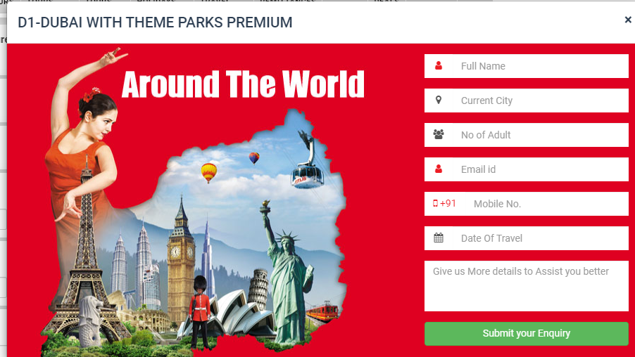

|  |
| --- |
| **TC40 :- To check the functionality of Regional Departure V pane-Header by clicking on Regional Departure V pane symbol.** |

w.findElement(By.*cssSelector*("div.ng-scope:nth-child(3) section.ng-scope:nth-child(3) div.container.container-mobile div.row.hidden-xs:nth-child(4) div.col-md-2.col-sm-3.filter-column v-accordion.vAccordion--default.ng-isolate-scope:nth-child(3) v-pane.shadow.panel.ng-scope.ng-isolate-scope.is-expanded:nth-child(1) v-pane-header.ng-scope.ng-isolate-scope:nth-child(1) div:nth-child(1) h4.panel-title.ng-scope > a:nth-child(1)")).click();

//Regional Departure V pane Header change to upward direction.

|  |
| --- |
| **TC41 :- To check the functionality of Departure Date V pane-Header by clicking on Departure Date V pane symbol** |

w.findElement(By.*cssSelector*("div.ng-scope:nth-child(3) section.ng-scope:nth-child(3) div.container.container-mobile div.row.hidden-xs:nth-child(4) div.col-md-2.col-sm-3.filter-column v-accordion.vAccordion--default.ng-isolate-scope:nth-child(3) v-pane.shadow.panel.ng-scope.ng-isolate-scope.is-expanded:nth-child(4) v-pane-header.ng-scope.ng-isolate-scope:nth-child(1) div:nth-child(1) h4.panel-title.ng-scope > a:nth-child(1)")).click();

//Departure Date V pane Header change to upward direction.

|  |
| --- |
| **TC42 :- To check the functionality of Tour type V pane Header by clicking on Tour Type V pane Header.** |

w.findElement(By.*cssSelector*("div.ng-scope:nth-child(3) section.ng-scope:nth-child(3) div.container.container-mobile div.row.hidden-xs:nth-child(4) div.col-md-2.col-sm-3.filter-column v-accordion.vAccordion--default.ng-isolate-scope:nth-child(3) v-pane.shadow.panel.ng-scope.ng-isolate-scope.is-expanded:nth-child(5) v-pane-header.ng-scope.ng-isolate-scope:nth-child(1) div:nth-child(1) h4.panel-title.ng-scope > a:nth-child(1)")).click();

//Tour Type V pane Header change to upward direction.

|  |
| --- |
| **TC43 :- To check the functionality of Go button (price) by entering min, max value and clicking on Go** |

w.findElement(By.*xpath*("//body/div[3]/section[1]/div[1]/div[1]/div[3]/div[1]/v-accordion[1]/v-pane[6]/v-pane-content[1]/div[1]/div[1]/form[1]/div[1]/div[1]/input[1]")).sendKeys("2000");

w.findElement(By.*xpath*("//body/div[3]/section[1]/div[1]/div[1]/div[3]/div[1]/v-accordion[1]/v-pane[6]/v-pane-content[1]/div[1]/div[1]/form[1]/div[1]/div[3]/input[1]")).sendKeys("5000");

w.findElement(By.*xpath*("//body/div[3]/section[1]/div[1]/div[1]/div[3]/div[1]/v-accordion[1]/v-pane[6]/v-pane-content[1]/div[1]/div[1]/form[1]/div[1]/div[4]/button[1]")).click();

// Tour packages are coming soon….

|  |
| --- |
| **TC44 :- To check the functionality of Go button (Duration) by entering min, max value and clicking on Go** |

w.findElement(By.*xpath*("//body/div[3]/section[1]/div[1]/div[1]/div[3]/div[1]/v-accordion[1]/v-pane[7]/v-pane-content[1]/div[1]/div[1]/form[1]/div[1]/div[1]/input[1]")).sendKeys("5000");

w.findElement(By.*xpath*("//body/div[3]/section[1]/div[1]/div[1]/div[3]/div[1]/v-accordion[1]/v-pane[7]/v-pane-content[1]/div[1]/div[1]/form[1]/div[1]/div[3]/input[1]")).sendKeys("10000");

//w.findElement(By.xpath("/html[1]/body[1]/div[3]/section[1]/div[1]/div[1]/div[3]/div[1]/v-accordion[1]/v-pane[7]/v-pane-content[1]/div[1]/div[1]/form[1]/div[1]/div[4]/button[1]")).click();

// Tour packages are coming soon….

|  |
| --- |
| **TC45 :- To check the functionality of Go button by selecting start date, end date and Month of travel by clicking on Go button.** |

w.findElement(By.*xpath*("//input[@id='startDatePicker']")).click();

Thread.*sleep*(2000);

w.findElement(By.*xpath*("//tbody/tr[6]/td[6]/button[1]/span[1]")).click();

Thread.*sleep*(2000);

w.findElement(By.*xpath*("//input[@id='endDatePicker']")).click();

Thread.*sleep*(2000);

w.findElement(By.*xpath*("//thead/tr[1]/th[3]/button[1]/i[1]")).click();

Thread.*sleep*(2000);

w.findElement(By.*xpath*("//span[contains(text(),'25')]")).click();

Thread.*sleep*(5000);

w.findElement(By.*xpath*("//body/div[3]/section[1]/div[1]/div[1]/div[3]/div[1]/v-accordion[1]/v-pane[8]/v-pane-content[1]/div[1]/div[1]/form[1]/div[1]/div[3]/div[1]/div[1]/span[1]/i[1]")).click();

w.findElement(By.*xpath*("//span[contains(text(),'June')]")).click();

w.findElement(By.*xpath*("//body/div[3]/section[1]/div[1]/div[1]/div[3]/div[1]/v-accordion[1]/v-pane[8]/v-pane-content[1]/div[1]/div[1]/form[1]/div[1]/div[4]/div[1]/button[1]")).click();

// Tour packages are coming soon….

|  |
| --- |
| **TC46::- To check the functionality of Group Tour button by clicking on Group tour button.** |

w.findElement(By.*cssSelector*("div.ng-scope:nth-child(3) section.ng-scope:nth-child(3) div.container.container-mobile div:nth-child(1) ol.breadcrumb:nth-child(1) li:nth-child(2) > a.ng-binding")).click();

//Back to home page of Group Tour page.

//Page will redirect to Group Tours home page.

|  |
| --- |
| **TC47 :- To check the functionality of ShriLanka and Maldives button by clicking on ShriLanka And Maldives button.** |

w.findElement(By.*cssSelector*("div.ng-scope:nth-child(3) section.custom-content.ng-scope div.container div.row div.col-md-2.col-sm-3.filter-column v-accordion.vAccordion--default.ng-isolate-scope v-pane.shadow.panel.ng-scope.ng-isolate-scope.is-expanded:nth-child(1) v-pane-content.ng-scope.ng-isolate-scope:nth-child(2) div.panel-content.ng-scope ul.list-unstyled.mb-0 li.ng-scope:nth-child(2) div.awesome-checkbox.awesome-checkbox--hover > a.label.ng-binding")).click();

//Shri Lanka And Maldives Tour page is open.

|  |
| --- |
| **TC148:- To check the functionality of Enquiry button by clicking on Enquiry button.** |

w.findElement(By.*linkText*("Enquiry")).click();

//Enquiry form is open.

|  |
| --- |
| TC **TC49:- To check the functionality of Submit button by entering valid data and clicking on submit button** |

w.findElement(By.*xpath*("//body/div[9]/div[1]/div[1]/div[1]/div[2]/form[1]/div[1]/div[1]/input[1]")).sendKeys("Komal Mhatre");

w.findElement(By.*xpath*("//body/div[9]/div[1]/div[1]/div[1]/div[2]/form[1]/div[2]/div[1]/input[1]")).sendKeys("pen");

w.findElement(By.*xpath*("//body/div[9]/div[1]/div[1]/div[1]/div[2]/form[1]/div[3]/div[1]/input[1]")).sendKeys("5");

w.findElement(By.*xpath*("//body/div[9]/div[1]/div[1]/div[1]/div[2]/form[1]/div[4]/div[1]/input[1]")).sendKeys("komal123@gmail.com");

w.findElement(By.*xpath*("//body/div[9]/div[1]/div[1]/div[1]/div[2]/form[1]/div[5]/div[1]/input[1]")).sendKeys("8760262198");

w.findElement(By.*xpath*("//body/div[9]/div[1]/div[1]/div[1]/div[2]/form[1]/div[6]/div[1]/input[1]")).click();

w.findElement(By.*xpath*("//span[contains(text(),'31')]")).click();

w.findElement(By.*xpath*("//body/div[9]/div[1]/div[1]/div[1]/div[2]/form[1]/div[7]/textarea[1]")).sendKeys("Not required......");

//w.findElement(By.xpath("//button[contains(text(),'Submit your Enquiry')]")).click();

w.findElement(By.*cssSelector*("body.modal-open:nth-child(2) div.modal.ng-isolate-scope.in:nth-child(20) div.modal-dialog.modal-lg div.modal-content div.ng-scope div.modal-header.modal-header--transparent.modal-header--bg > button.close")).click();

//not submitting form on system.

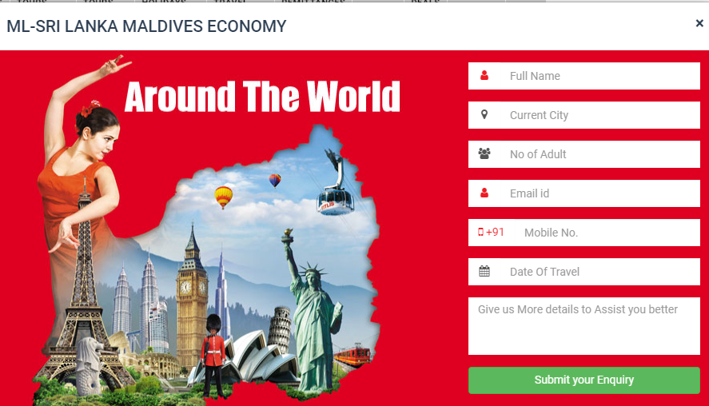

|  |
| --- |
| **TC50 :- To check the functionality of V pane Headers and Go buttons in Shri Lanka and Maldives.** |

System.***out***.println(w.findElement(By.*xpath*("//body/div[3]/section[1]/div[1]/div[1]/div[3]/div[1]/h4[2]")).getText());

Thread.*sleep*(2000);

w.findElement(By.*cssSelector*("div.ng-scope:nth-child(3) section.ng-scope:nth-child(3) div.container.container-mobile div.row.hidden-xs:nth-child(4) div.col-md-2.col-sm-3.filter-column v-accordion.vAccordion--default.ng-isolate-scope:nth-child(3) v-pane.shadow.panel.ng-scope.ng-isolate-scope.is-expanded:nth-child(1) v-pane-header.ng-scope.ng-isolate-scope:nth-child(1) div:nth-child(1) h4.panel-title.ng-scope > a:nth-child(1)")).click();

w.findElement(By.*cssSelector*("div.ng-scope:nth-child(3) section.ng-scope:nth-child(3) div.container.container-mobile div.row.hidden-xs:nth-child(4) div.col-md-2.col-sm-3.filter-column v-accordion.vAccordion--default.ng-isolate-scope:nth-child(3) v-pane.shadow.panel.ng-scope.ng-isolate-scope.is-expanded:nth-child(4) v-pane-header.ng-scope.ng-isolate-scope:nth-child(1) div:nth-child(1) h4.panel-title.ng-scope > a:nth-child(1)")).click();

w.findElement(By.*cssSelector*("div.ng-scope:nth-child(3) section.ng-scope:nth-child(3) div.container.container-mobile div.row.hidden-xs:nth-child(4) div.col-md-2.col-sm-3.filter-column v-accordion.vAccordion--default.ng-isolate-scope:nth-child(3) v-pane.shadow.panel.ng-scope.ng-isolate-scope.is-expanded:nth-child(5) v-pane-header.ng-scope.ng-isolate-scope:nth-child(1) div:nth-child(1) h4.panel-title.ng-scope > a:nth-child(1)")).click();

w.findElement(By.*xpath*("//body/div[3]/section[1]/div[1]/div[1]/div[3]/div[1]/v-accordion[1]/v-pane[6]/v-pane-content[1]/div[1]/div[1]/form[1]/div[1]/div[1] /input[1]")).sendKeys("2000");

w.findElement(By.*xpath*("//body/div[3]/section[1]/div[1]/div[1]/div[3]/div[1]/v-accordion[1]/v-pane[6]/v-pane-content[1]/div[1]/div[1]/form[1]/div[1]/div[3]/input[1]")).sendKeys("5000");

w.findElement(By.*xpath*("//body/div[3]/section[1]/div[1]/div[1]/div[3]/div[1]/v-accordion[1]/v-pane[6]/v-pane-content[1]/div[1]/div[1]/form[1]/div[1]/div[4] /button[1]")).click();

System.***out***.println("Your Tour Package of ShriLanka And Maldive is Coming Soon......");

Thread.*sleep*(2000);

//Print available tour packages on console.

//Tour packages are coming soon….

|  |
| --- |
| **TC51 :- To check Available Tours options and back to Group tours package.** |

System.***out***.println(w.findElement(By.*xpath*("//body/div[3]/section[1]/div[1]/div[1]/div[3]/div[1]/h4[2]")).getText());

Thread.*sleep*(3000);

w.navigate().back();

w.findElement(By.*cssSelector*("div.ng-scope:nth-child(3) section.ng-scope:nth-child(3) div.container.container-mobile div:nth-child(1) ol.breadcrumb:nth-child(1) li:nth-child(2) > a.ng-binding")).click();

System.***out***.println("THANK YOU for visiting Group Tours");

//Print available tour options on console and back to Group tour sub module.

|  |
| --- |
| **TC52 :- MINIMIZE and MAXIMIZE the Group tour submodule page.** |

JavascriptExecutor js= (JavascriptExecutor)w;

js.executeScript("window.scrollBy(0, 2000)");

Thread.*sleep*(2000);

js.executeScript("window.scrollBy(0, -2000)");

Thread.*sleep*(5000);

|  |
| --- |
| **TC53 :- To check the Andaman sub module in Indian Group tours.** |

System.***out***.println("Check for Indian Tours");

Thread.*sleep*(3000);

w.findElement(By.*cssSelector*("div.ng-scope:nth-child(3) section.custom-content.ng-scope div.container div.row div.col-md-2.col-sm-3.filter-column v-accordion. vAccordion--default.ng-isolate-scope v-pane.shadow.panel.ng-scope.ng-isolate-scope.is-expanded:nth-child(2) v-pane-content.ng-scope.ng-isolate-scope:nth-child (2) div.ng-scope div.panel-content ul.list-unstyled li.ng-scope:nth-child(1) div. awesome-checkbox.awesome-checkbox--hover > a.label.ng-binding")).click();

Thread.*sleep*(5000);

System.***out***.println("Andaman Tours Packages.");

//ANDAMAN tours page open successfully.

|  |
| --- |
| **TC54 :- To check the ANDAMAN MFL enquiry.** |

w.findElement(By.*xpath*("//*[@id=\"main\"]/div[3]/div[2]/div[2]/div[1]/article/figure/div[2]/div[2]/a")).click();

Thread.*sleep*(5000);

//Enquiry form open successfully.

|  |
| --- |
| **TC55 :- To submit the ANDAMAN MFL enquiry form .** |

w.findElement(By.*xpath*("//body/div[9]/div[1]/div[1]/div[1]/div[2]/form[1]/div[1]/div[1]/input[1]")).sendKeys("komal Mhatre");

w.findElement(By.*xpath*("//body/div[9]/div[1]/div[1]/div[1]/div[2]/form[1]/div[2]/div[1]/input[1]")).sendKeys("Raigad");

w.findElement(By.*xpath*("//body/div[9]/div[1]/div[1]/div[1]/div[2]/form[1]/div[3]/div[1]/input[1]")).sendKeys("09");

w.findElement(By.*xpath*("//body/div[9]/div[1]/div[1]/div[1]/div[2]/form[1]/div[4]/div[1]/input[1]")).sendKeys("komal123@gmail.com");

w.findElement(By.*xpath*("//body/div[9]/div[1]/div[1]/div[1]/div[2]/form[1]/div[5]/div[1]/input[1]")).sendKeys("8765432198");

w.findElement(By.*xpath*("//body/div[9]/div[1]/div[1]/div[1]/div[2]/form[1]/div[6]/div[1]/input[1]")).click();

w.findElement(By.*xpath*("//thead/tr[1]/th[3]/button[1]/i[1]")).click();

w.findElement(By.*xpath*("//span[contains(text(),'17')]")).click();

w.findElement(By.*xpath*("//body/div[9]/div[1]/div[1]/div[1]/div[2]/form[1]/div[7]/textarea[1]")).sendKeys("Not required......");

Thread.*sleep*(5000);

w.findElement(By.*xpath*("//body/div[9]/div[1]/div[1]/div[1]/div[1]/button[1]")).click();

//not working on system.

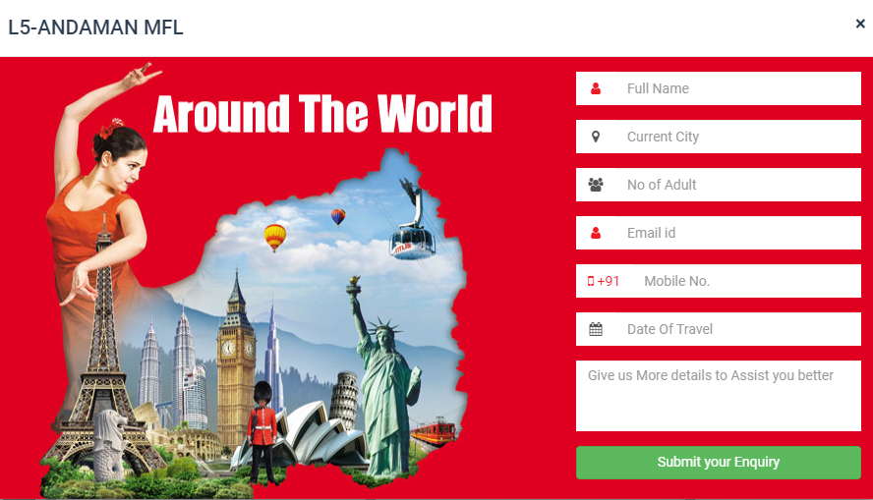

|  |
| --- |
| **TC56 :- Get the text from text field for available ANDAMAN tours.** |

System.***out***.println(w.findElement(By.*xpath*("//body/div[3]/section[1]/div[1]/div[1]/div[3]/div[1]/h4[2]")).getText());

Thread.*sleep*(2000);

|  |
| --- |
| **TC57:- To check the V pane for REGIONAL DEPARTURE, DEPARTURE DATE and TOUR TYPES.** |

//Print available tours options on console.

w.findElement(By.*cssSelector*("div.ng-scope:nth-child(3) section.ng-scope:nth-child(3) div.container.container-mobile div.row.hidden-xs:nth-child(4) div.col-md-2.col-sm-3.filter-column v-accordion.vAccordion--default.ng-isolate-scope:nth-child(3) v-pane.shadow.panel.ng-scope.ng-isolate-scope.is-expanded:nth-child(1) v-pane-header.ng-scope.ng-isolate-scope:nth-child(1) div:nth-child(1) h4.panel-title.ng-scope > a:nth-child(1)")).click();

w.findElement(By.*cssSelector*("div.ng-scope:nth-child(3) section.ng-scope:nth-child(3) div.container.container-mobile div.row.hidden-xs:nth-child(4) div.col-md-2.col-sm-3.filter-column v-accordion.vAccordion--default.ng-isolate-scope:nth-child(3) v-pane.shadow.panel.ng-scope.ng-isolate-scope.is-expanded:nth-child(4) v-pane-header.ng-scope.ng-isolate-scope:nth-child(1) div:nth-child(1) h4.panel-title.ng-scope > a:nth-child(1)")).click();

w.findElement(By.*cssSelector*("div.ng-scope:nth-child(3) section.ng-scope:nth-child(3) div.container.container-mobile div.row.hidden-xs:nth-child(4) div.col-md-2.col-sm-3.filter-column v-accordion.vAccordion--default.ng-isolate-scope:nth-child(3) v-pane.shadow.panel.ng-scope.ng-isolate-scope.is-expanded:nth-child(5) v-pane-header.ng-scope.ng-isolate-scope:nth-child(1) div:nth-child(1) h4.panel-title.ng-scope > a:nth-child(1)")).click();

//REGIONAL DEPARTURE, DEPARTURE DATE and TOUR TYPE V pane Header moves upwards.

|  |
| --- |
| **TC58 :- To check the functionality of Go button by entering min price and max price by clicking on Go button** |

w.findElement(By.*xpath*("//body/div[3]/section[1]/div[1]/div[1]/div[3]/div[1]/v-accordion[1]/v-pane[6]/v-pane-content[1]/div[1]/div[1]/form[1]/div[1]/div[1]/input[1]")).sendKeys("23000");

w.findElement(By.*xpath*("//body/div[3]/section[1]/div[1]/div[1]/div[3]/div[1]/v-accordion[1]/v-pane[6]/v-pane-content[1]/div[1]/div[1]/form[1]/div[1]/div[3]/input[1]")).sendKeys("70000");

w.findElement(By.*xpath*("//body/div[3]/section[1]/div[1]/div[1]/div[3]/div[1]/v-accordion[1]/v-pane[6]/v-pane-content[1]/div[1]/div[1]/form[1]/div[1]/div[4]/button[1]")).click();

// Tour packages are coming soon….

|  |
| --- |
| **TC59 :- To check the functionality of Go button by entering min duration and max duration by clicking on Go button.** |

w.findElement(By.*xpath*("//body/div[3]/section[1]/div[1]/div[1]/div[3]/div[1]/v-accordion[1]/v-pane[7]/v-pane-content[1]/div[1]/div[1]/form[1]/div[1]/div[1]/input[1]")).sendKeys("20000");

w.findElement(By.*xpath*("//body/div[3]/section[1]/div[1]/div[1]/div[3]/div[1]/v-accordion[1]/v-pane[7]/v-pane-content[1]/div[1]/div[1]/form[1]/div[1]/div[3]/input[1]")).sendKeys("30000");

w.findElement(By.*xpath*("//body/div[3]/section[1]/div[1]/div[1]/div[3]/div[1]/v-accordion[1]/v-pane[7]/v-pane-content[1]/div[1]/div[1]/form[1]/div[1]/div[4]/button[1]")).click();

// tour packages are coming soon….

|  |
| --- |
| **TC60 :- To check the functionality of Go button by selecting start date and end date and month by clicking on Go button** |

w.findElement(By.*xpath*("//input[@id='startDatePicker']")).click();

w.findElement(By.*xpath*("//thead/tr[1]/th[3]/button[1]/i[1]")).click();

w.findElement(By.*xpath*("//span[contains(text(),'17')]")).click();

Thread.*sleep*(2000);

w.findElement(By.*xpath*("//input[@id='endDatePicker']")).click();

w.findElement(By.*xpath*("//thead/tr[1]/th[3]/button[1]")).click();

w.findElement(By.*xpath*("//tbody/tr[5]/td[3]/button[1]")).click();

Thread.*sleep*(2000);

//tour packages are coming soon….

|  |
| --- |
| **TC61 :- Go back to INDIAN GROUP TOUR package.** |

w.findElement(By.*cssSelector*("div.ng-scope:nth-child(3) section.ng-scope:nth-child(3) div.container.container-mobile div:nth-child(1) ol.breadcrumb:nth-child(1) li:nth-child(2) > a.ng-binding")).click();

Thread.*sleep*(5000);

System.***out***.println("THANK YOU for visiting ANDAMAN Tours");

//Reach to INDIAN GROUP TOUR package.

|  |
| --- |
| **TC62 :- To check the functionality of ANDRA PRADESH package.** |

w.findElement(By.*cssSelector*("div.ng-scope:nth-child(3) section.custom-content.ng-scope div.container div.row div.col-md-2.col-sm-3.filter-column v-accordion.vAccordion--default.ng-isolate-scope v-pane.shadow.panel.ng-scope.ng-isolate-scope.is-expanded:nth-child(2) v-pane-content.ng-scope.ng-isolate-scope:nth-child(2) div.ng-scope div.panel-content ul.list-unstyled li.ng-scope:nth-child(2) div.awesome-checkbox.awesome-checkbox--hover > a.label.ng-binding")).click();

Thread.*sleep*(5000);

System.***out***.println("Andra Pradesh Tours Packages.");

//ANDRA PRADDESH tour submodule open successfully.

|  |
| --- |
| **TC63 :- To check the functionality of VIEW DETAILS button.** |

w.findElement(By.*cssSelector*("div.ng-scope:nth-child(3) section.ng-scope:nth-child(3) div.container.container-mobile div.row.hidden-xs:nth-child(4) div.col-md-10.col-sm-9.col-xs-12 div.row.ng-scope:nth-child(2) div.col-md-4.col-sm-6.col-xs-12.ng-scope:nth-child(1) article.box figure.badge-container div.box__details:nth-child(7) div.action-btn.ng-scope > a.btn.btn-grey.ng-scope:nth-child(1)")).click();

Thread.*sleep*(5000);

w.findElement(By.*xpath*("//button[contains(text(),'Aug')]")).click();

w.findElement(By.*xpath*("//tbody/tr[1]/td[1]/div[1]/p[2]")).click();

Thread.*sleep*(3000);

w.findElement(By.*xpath*("//body/div[9]/div[1]/div[1]/div[1]/div[1]/div[1]/button[1]")).click();

Thread.*sleep*(3000);

w.findElement(By.*xpath*("//tbody/tr[1]/td[1]/div[2]/p[1]")).click();

Thread.*sleep*(3000);

w.findElement(By.*xpath*("//body/div[9]/div[1]/div[1]/div[1]/div[1]/div[1]/button[1]")).click();

Thread.*sleep*(5000);

System.***out***.println("Tour Price Details Display");

Thread.*sleep*(5000);

w.findElement(By.*cssSelector*("div.ng-scope:nth-child(3) section.ng-scope:nth-child(3) div.container div.row:nth-child(3) div.col-md-9.col-xs-12 div.row div.col-xs-12 div.tab-container:nth-child(1) ul.nav.nav-tabs.nav-tabs-style-1 li.ng-scope:nth-child(2) > a:nth-child(1)")).click();

Thread.*sleep*(5000);

w.navigate().back();

Thread.*sleep*(5000);

//Details of HYDRABAD RAMOJI submodule view successfully.

|  |
| --- |
| **TC64 :- To check the DATE AND COST button in HYDRABAD RAMOJI sub module.** |

w.findElement(By.*xpath*("//*[@id=\"main\"]/div[3]/div[2]/div[2]/div[1]/article/figure/div[7]/div[2]/a[2]")).click();

Thread.*sleep*(5000); w.findElement(By.*xpath*("//button[contains(text(),'Close')]")).click();

Thread.*sleep*(5000);

// DATE AND COST has checked successfully.

|  |
| --- |
| **TC65 :- To check the functionality of Enquiry button in HYDRABAD RAMOJI submodule.** |

w.findElement(By.*cssSelector*("div.ng-scope:nth-child(3) section.ng-scope:nth-child(3) div.container.container-mobile div.row.hidden-xs:nth-child(4) div.col-md-10.col-sm-9.col-xs-12 div.row.ng-scope:nth-child(2) div.col-md-4.col-sm-6.col-xs-12.ng-scope:nth-child(1) article.box figure.badge-container div.box__details:nth-child(7) div.action-btn.ng-scope > a.btn.btn-grey:nth-child(3)")).click();

Thread.*sleep*(5000);

//Enquiry form of HYDRABAD RAMOJI is open successfully.

|  |
| --- |
| **TC67 :- To check the functionality of submit button in HYDRABAD RAMOJI Enquiry submodule.** |

w.findElement(By.xpath("//*[@id=\"main\"]/div[3]/div[2]/div[2]/div[1]/article/figure/div[7]/div[2]/a[3]")).sendKeys("Komal");

w.findElement(By.xpath("//body/div[9]/div[1]/div[1]/div[1]/div[2]/form[1]/div[2]/div[1]/input[1]")).sendKeys("alibag");

w.findElement(By.xpath("//body/div[9]/div[1]/div[1]/div[1]/div[2]/form[1]/div[3]/div[1]/input[1]")).sendKeys("7");

w.findElement(By.xpath("//body/div[9]/div[1]/div[1]/div[1]/div[2]/form[1]/div[4]/div[1]/input[1]")).sendKeys("komal@gmail.com");

w.findElement(By.xpath("//body/div[9]/div[1]/div[1]/div[1]/div[2]/form[1]/div[5]/div[1]/input[1]")).sendKeys("8765432789");

w.findElement(By.xpath("//body/div[9]/div[1]/div[1]/div[1]/div[2]/form[1]/div[6]/div[1]/input[1]")).click();

w.findElement(By.xpath("//span[contains(text(),'31')]")).click();

w.findElement(By.xpath("//body/div[9]/div[1]/div[1]/div[1]/div[2]/form[1]/div[7]/textarea[1]")).sendKeys("not Required....");

w.findElement(By.xpath("//body/div[9]/div[1]/div[1]/div[1]/div[1]/button[1]")).click();

Thread.sleep(5000);

w.findElement(By.*xpath*("//body/div[9]/div[1]/div[1]/div[1]/div[1]/button[1]")).

click(); Thread.*sleep*(4000);

//Element unable to locate.

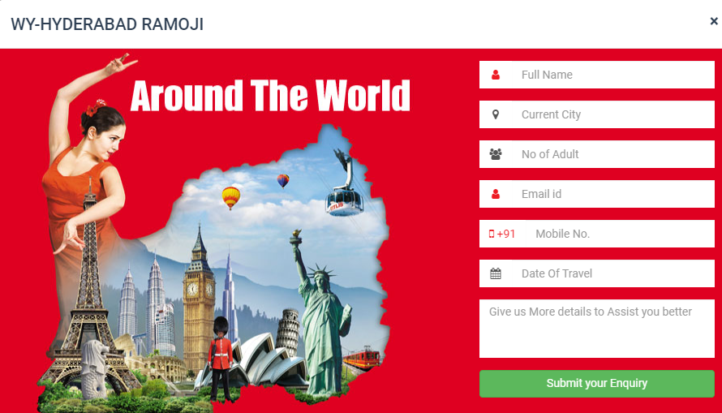

|  |
| --- |
| **TC68 :- To check the functionality of Enquiry button in PITHAPURAM KURAVPUR SHRISALAM submodule.** |

w.findElement(By.*cssSelector*("div.ng-scope:nth-child(3) section.ng-scope:nth-child(3) div.container.container-mobile div.row.hidden-xs:nth-child(4) div.col-md-10.col-sm-9.col-xs-12 div.row.ng-scope:nth-child(2) div.col-md-4.col-sm-6.col-xs-12.ng-scope:nth-child(2) article.box figure.badge-container div.box__details div.action-btn.ng-scope > a.btn.btn-grey")).click();

Thread.*sleep*(3000);

**//**Enquiry form of PTHAPURAM KURAVPUR SHRISAILAM is open successfully.

|  |
| --- |
| **TC69 :- To check the functionality of Submit button in PITHAPURAM KURAVPUR SHRISALAM Enquiry.** |

w.findElement(By.*xpath*("//body/div[9]/div[1]/div[1]/div[1]/div[2]/form[1]/div[1]/div[1]/input[1]")).sendKeys("komal");

w.findElement(By.*xpath*("//body/div[9]/div[1]/div[1]/div[1]/div[2]/form[1]/div[2]/div[1]/input[1]")).sendKeys("panvel");

w.findElement(By.*xpath*("//body/div[9]/div[1]/div[1]/div[1]/div[2]/form[1]/div[3]/div[1]/input[1]")).sendKeys("7");

w.findElement(By.*xpath*("//body/div[9]/div[1]/div[1]/div[1]/div[2]/form[1]/div[4]/div[1]/input[1]")).sendKeys("komal@gmail.com");

w.findElement(By.*xpath*("//body/div[9]/div[1]/div[1]/div[1]/div[2]/form[1]/div[5]/div[1]/input[1]")).sendKeys("9876543212");

w.findElement(By.*xpath*("//body/div[9]/div[1]/div[1]/div[1]/div[2]/form[1]/div[6]/div[1]/input[1]")).click();

w.findElement(By.*xpath*("//tbody/tr[6]/td[7]/button[1]")).click();

w.findElement(By.*xpath*("//body/div[9]/div[1]/div[1]/div[1]/div[2]/form[1]/div[7]/textarea[1]")).sendKeys("incomplete site");

Thread.*sleep*(2000);

w.findElement(By.*xpath*("//body/div[9]/div[1]/div[1]/div[1]/div[1]/button[1]")).click();

System.***out***.println("Pithapuram Kuravpur Enquiry submited.");

Thread.*sleep*(6000);

**//**Enquiry form of PITHAPURAM KURAVPUR SHRISAILAM is not working on system.

|  |
| --- |
| **TC70 :- To check the functionality of Go button by entering min price, max price by clicking on Go button.** |

//Regional Departure

w.findElement(By.*xpath*("//body/div[3]/section[1]/div[1]/div[1]/div[3]/div[1]/v-accordion[1]/v-pane[1]/v-pane-content[1]/div[1]/div[1]/ul[1]/li[1]/div[1]/label[1]")).click();

System.***out***.println("Mumbai Tours Packages are coming soon....");

Thread.*sleep*(5000);

w.findElement(By.*xpath*("//body/div[3]/section[1]/div[1]/div[1]/div[3]/div[1]/v-accordion[1]/v-pane[1]/v-pane-content[1]/div[1]/div[1]/ul[1]/li[2]/div[1]/label[1]")).click();

System.***out***.println("Banguluru Tours Packages are coming soon....");

Thread.*sleep*(3000);

//Tour packages are coming soon….

|  |
| --- |
| **TC71 :- To check the functionality of Go button by entering min duration, max duration by clicking on Go button.** |

//departure Part

w.findElement(By.*xpath*("//body/div[3]/section[1]/div[1]/div[1]/div[3]/div[1]/v-accordion[1]/v-pane[2]/v-pane-content[1]/div[1]/div[1]/ul[1]/li[1]/div[1]/label[1]")).click();

System.***out***.println("August2021 Tours Packages are coming soon....");

Thread.*sleep*(5000);

// w.findElement(By.xpath("//body/div[3]/section[1]/div[1]/div[1]/div[3]/div[1]/v-accordion[1]/v-pane[2]/v-pane-content[1]/div[1]/div[1]/ul[1]/li[2]/div[1]/label[1]")).click();

System.***out***.println("September 2021 Tours Packages are coming soon....");

**//** Tour packages are coming soon….

//Back to Indian Tours

|  |
| --- |
| **TC72 :- Back to INDIAN TOURS package from ANDRA PRADESH sub module.** |

w.findElement(By.*cssSelector*("div.ng-scope:nth-child(3) section.ng-scope:nth-child(3) div.container.container-mobile div:nth-child(1) ol.breadcrumb:nth-child(1) li:nth-child(2) > a.ng-binding")).click();

System.***out***.println("THANK YOU for visiting ANDRA PRADESH Tours");

//Back to INDIAN GROUP TOUR successfully.

|  |
| --- |
| **TC73 :- To Check the CHOTA TOUR sub module in SPECIALITY TOURS module** |

Actions a=**new** Actions(w);

WebElement wb=w.findElement(By.*cssSelector*("div.ng-scope:nth-child(2) header.navbar-static-top.ng-scope:nth-child(2) div.topnav.custom-topnav.hidden-xs.hidden-sm div.container nav.hidden-xs.hidden-sm ul.menu.list-unstyled.mb-0 li.menu-item-has-children:nth-child(2) > a:nth-child(1)"));

a.moveToElement(wb).build().perform();

Thread.*sleep*(3000);

w.findElement(By.*xpath*("//*[@id=\"main-menu\"]/ul/li[2]/ul/li[1]/a")).click();

System.***out***.println("Welcome To Chota Break Tours Packages.");

Thread.*sleep*(5000);

//Chota tour package open successfully.

|  |
| --- |
| **TC74 :- To Check the DEPARTURE CITY packages in Chota Tour module.** |

w.findElement(By.*xpath*("//body/div[3]/section[1]/div[1]/div[1]/div[1]/div[1]/h4[1]")).getText();

Thread.*sleep*(5000);

//left side

w.findElement(By.*xpath*("//label[contains(text(),'Mumbai')]")).click();

System.***out***.println("Mumbai Tour Package is Coming Soon");

Thread.*sleep*(5000);

w.findElement(By.*xpath*("//label[contains(text(),'Cochin')]")).click();

System.***out***.println("Cochin Tour Package is Coming Soon");

Thread.*sleep*(5000);

//Tour packages are coming soon….

|  |
| --- |
| **TC75 :- To Check the Chota Break Tours** |

w.findElement(By.*xpath*("//*[@id=\"main\"]/ol/li[2]/a")).click();

Thread.*sleep*(5000);

w.findElement(By.*xpath*("//*[@id=\"main\"]/div/div[1]/v-accordion/v-pane/v-pane-content/div/div/ul/li[1]/div/a")).click();

Thread.*sleep*(5000);

//Chota Break Tour page open successfully.

|  |
| --- |
| **TC76 :- To Check functionality of VIEW DETAILS button of COIMBATOR sub module.** |

w.findElement(By.*xpath*("//*[@id=\"main\"]/div[1]/div[2]/div[2]/div[1]/article/figure/div[6]/a/ul[1]")).click();

Thread.*sleep*(7000);

w.findElement(By.*xpath*("//*[@id=\"main\"]/div[3]/div[2]/div/div[1]/ul[1]/li[1]/button")).click();

w.findElement(By.*xpath*("//*[@id=\"tbody\"]/table/tbody/tr[1]/td[1]/div[1]/p[2]")).click();

Thread.*sleep*(3000);

w.findElement(By.*xpath*("//*[@id=\"room-booking\"]/div/div[1]/button")).click();

Thread.*sleep*(3000);

System.***out***.println("Tour Price Details Display");

w.findElement(By.*xpath*("//*[@id=\"myCarousel\"]/div[2]/div[2]/button")).click();

Thread.*sleep*(5000);

//Check all Details of COIMBATORE sub module.

|  |
| --- |
| **TC77 :- Visit to HONEYMOON SPECIAL TOUR** |

Actions a1=**new** Actions(w);

WebElement wb1=w.findElement(By.*cssSelector*("div.ng-scope:nth-child(2) header.navbar-static-top.ng-scope:nth-child(2) div.topnav.custom-topnav.hidden-xs.hidden-sm div.container nav.hidden-xs.hidden-sm ul.menu.list-unstyled.mb-0 li.menu-item-has-children:nth-child(2) > a:nth-child(1)"));

a1.moveToElement(wb1).build().perform();

Thread.*sleep*(3000);

//Honeymoon Special

w.findElement(By.*xpath*("//*[@id=\"main-menu\"]/ul/li[2]/ul/li[2]/a")).click();

System.***out***.println("Welcome To Honeymoon Special Tours Packages.\n");

Thread.*sleep*(6000);

//HONEYMOON SPECIAL TOUR page open successfully.

|  |
| --- |
| **TC78 :- To check functionality of MUNNAR KODAIKONAL OOTY Enquiry button.** |

w.findElement(By.*xpath*("//*[@id=\"main\"]/div[1]/div[2]/div[2]/div[3]/article/figure/div[2]/div[2]/a")).click();

Thread.*sleep*(4000);

**//**Enquiry form of MUNNAR KODAIKONAL OOTY is open successfully.

|  |
| --- |
| **TC79 :- Check for DEPARTURE CITTY sub modules.** |

w.findElement(By.*xpath*("//*[@id=\"main\"]/div[1]/div[1]/v-accordion/v-pane[1]/v-pane-content/div/div/ul/li[2]/div/label")).click();

Thread.*sleep*(5000);

w.findElement(By.*xpath*("//*[@id=\"main\"]/div[1]/div[1]/v-accordion/v-pane[1]/v-pane-content/div/div/ul/li[4]/div/label")).click();

Thread.*sleep*(5000);

w.findElement(By.*xpath*("//*[@id=\"main\"]/div[1]/div[1]/v-accordion/v-pane[1]/v-pane-content/div/div/ul/li[5]/div/label")).click();

Thread.*sleep*(5000);

//Tour packages are coming soon….

|  |
| --- |
| **TC80 :- Back to SPECIALITY TOUR** |

w.findElement(By.*xpath*("//*[@id=\"main\"]/ol/li[2]/a")).click();

w.manage().window().maximize();

JavascriptExecutor js= (JavascriptExecutor)w;

Thread.*sleep*(4000);

js.executeScript("window.scrollBy(0, 2000)");

Thread.*sleep*(4000);

js.executeScript("window.scrollBy(0, -2000)");

Thread.*sleep*(5000);

**//**Successfully back to Speciality tour and Scroll DOWN and Scroll Up the Window.

|  |
| --- |
| **TC81 :- Visit to MARIGOLD Tour** |

w.findElement(By.*cssSelector*("div.ng-scope:nth-child(3) section.ng-scope:nth-child(2) div.container div.row div.col-md-2.col-sm-3.hidden-xs v-accordion.vAccordion--default.ng-isolate-scope v-pane.shadow.panel.ng-scope.ng-isolate-scope.is-expanded v-pane-content.ng-scope.ng-isolate-scope:nth-child(2) div.panel-content.ng-scope ul.list-unstyled.mb-0 li.ng-scope:nth-child(3) div.awesome-checkbox.awesome-checkbox--hover > a.label.ng-binding")).click();

System.***out***.println("Welcome To Marigold Tours Packages.\n");

Thread.*sleep*(5000);

w.findElement(By.*cssSelector*("div.ng-scope:nth-child(3) section.custom-content.ng-scope div.container.container-mobile div:nth-child(1) ol.breadcrumb:nth-child(1) li:nth-child(2) > a.ng-binding")).click();

Thread.*sleep*(5000);

//Visited To marigold tour and back to Speciality tour packages .

|  |
| --- |
| **TC82 :- Visit to MY FAIR LADY Tour** |

w.findElement(By.*cssSelector*("div.ng-scope:nth-child(3) section.ng-scope:nth-child(2) div.container div.row div.col-md-2.col-sm-3.hidden-xs v-accordion.vAccordion--default.ng-isolate-scope v-pane .shadow.panel.ng-scope.ng-isolate-scope.is-expanded v-pane-content.ng-scope.ng-isolate-scope:nth -child(2) div.panel-content.ng-scope ul.list-unstyled.mb-0 li.ng-scope:nth-child(4) div.awesome-checkbox.awesome-checkbox--hover > a.label.ng-binding")).click(); System.***out***.println("Welcome To My Fair Lady Tours Packages.\n");

Thread.*sleep*(5000);

w.findElement(By.*cssSelector*("div.ng-scope:nth-child(3) section.custom-content.ng-scope div.container.container-mobile div:nth-child(1) ol.breadcrumb:nth-child(1) li:nth-child(2) > a.ng-binding")).click();

Thread.*sleep*(5000);

//Visited To MY FAIR LADY tour and back to Speciality tour packages

|  |
| --- |
| **TC83:- Check for ECONOMY TOUR module.** |

w.findElement(By.*xpath*("//*[@id=\"main-menu\"]/ul/li[3]/a")).click();

System.***out***.println("Welcome to Economy Tours\t \n **** Here you will get Low Price Tours ****\n ");

Thread.*sleep*(3000);

System.***out***.println(w.findElement(By.*xpath*("//*[@id=\"main\"]/div[1]/div[1]/h4")). getText());

Thread.*sleep*(5000);

//ECONOMY TOUR package is open.

|  |
| --- |
| **TC84 :- Check for MAGICAL MANALI ECONOMY tour** |

w.findElement(By.*xpath*("//*[@id=\"main\"]/div[1]/div[2]/div[2]/div[1]/article/figure/div[22]/a/ul[1]/li[6]")).click();

Thread.*sleep*(5000);

System.***out***.println("Welcome to MAGICAL MANALI ECONOMY");

w.manage().window().maximize();

JavascriptExecutor js= (JavascriptExecutor)w;

Thread.*sleep*(4000);

js.executeScript("window.scrollBy(0, 2000)");

Thread.*sleep*(4000);

js.executeScript("window.scrollBy(0, -2000)");

Thread.*sleep*(5000);

w.findElement(By.*xpath*("//*[@id=\"myCarousel\"]/div[2]/div[2]/button")).click();

Thread.*sleep*(5000);

**//**MAGICAL MANALI ECONOMY TOUR package is open successfully.

//Window Scroll up and Scroll Down successfully.

// Back to ECONOMY TOUR home page.

|  |
| --- |
| **TC85:- Check for KASHMIR ECONOMY TOUR.** |

w.findElement(By.*xpath*("//*[@id=\"main\"]/div[1]/div[2]/div[2]/div[2]/article/figure/div[10]/a/ul[1]")).click();

Thread.*sleep*(5000);

System.***out***.println("Welcome to KASHMIR ECONOMY");

Thread.*sleep*(4000);

JavascriptExecutor js1= (JavascriptExecutor)w;

Thread.*sleep*(4000);

js1.executeScript("window.scrollBy(0, 2000)");

Thread.*sleep*(4000);

js1.executeScript("window.scrollBy(0, -2000)");

Thread.*sleep*(5000);

w.findElement(By.*xpath*("//*[@id=\"myCarousel\"]/div[2]/div[2]/button")).click(); Thread.*sleep*(4000);

// Visited to KASHMIR ECONOMY package

//Window Scroll Down and Scroll Up

//Back to ECONOMY TOUR home page.

|  |
| --- |
| **TC86 :- Check for DEPARTURE CITY** |

w.findElement(By.*xpath*("//*[@id=\"Mumbai\"]")).click();

System.***out***.println("Your packages are coming soon");

Thread.*sleep*(5000);

w.findElement(By.*xpath*("//*[@id=\"main\"]/ol/li[2]/a")).click();

//Tour packages are coming soon…

// Back to ECONOMY TOUR home page.

|  |
| --- |
| **TC87 :- Check for TAILOREMADE HOLIDAYS packages.** |

Actions a=**new** Actions(w);

WebElement wb=w.findElement(By.*cssSelector*("div.ng-scope:nth-child(2) header.navbar-static-top.ng-scope:nth-child(2) div.topnav.custom-topnav.hidden-xs.hidden-sm div.container nav.hidden-xs.hidden-sm ul.menu.list-unstyled.mb-0 li.megamenu-menu.tailor-made:nth-child(4) > a.text-uppercase"));

a.moveToElement(wb).click().build().perform();

System.***out***.println("Welcome to Tailormade Holidays");

Thread.*sleep*(3000);

**//TAILORMADE HOLIDAY package open successfully.**

|  |
| --- |
| **TC88 :- To check AFRICA package submodule.** |

w.findElement(By.*xpath*("//*[@id=\"tailor-made-holidays\"]/div/div/div[1]/ul/li[1]/ul/li[1]/a")).click();

Thread.*sleep*(5000);

System.*out*.println(w.findElement(By.*xpath*("//body/div[3]/section[1]/div[1]/div[1]/div[1]/div[1]/h4[1]")).getText());

Thread.*sleep*(5000);

//AFRICA submodule open successfully.

// Available tour options print on console.

|  |
| --- |
| **TC89 :- Click on V pane Header** |

w.findElement(By.*xpath*("//v-pane-header")).click();

w.findElement(By.*xpath*("//*[@id=\"fit\"]/div/div/div/article/div[2]/div[2]/a[1]")).click();

Thread.*sleep*(3000);

//Clicking on Price and Duration V pane Headers.

|  |
| --- |
| **TC90 :- To check the functionality of FAQ button.** |

w.findElement(By.*xpath*("//*[@id=\"main\"]/div/div[1]/div[2]/div/div/ul/li[4]/a")).click();

Thread.*sleep*(3000);

w.navigate().back();

//Click om FAQ button and back to BOTSWANA tour package.

|  |
| --- |
| **TC91 :- Visit to COMBODIA tour submodule.** |

Actions a1=**new** Actions(w);

WebElement wb1=w.findElement(By.*cssSelector*("div.ng-scope:nth-child(2) header.navbar-static-top.ng-scope:nth-child(2) div.topnav.custom-topnav.hidden-xs.hidden-sm div.container nav.hidden-xs.hidden-sm ul.menu.list-unstyled.mb-0 li.megamenu-menu.tailor-made:nth-child(4) > a.text-uppercase"));

a1.moveToElement(wb1).build().perform();

Thread.*sleep*(3000);

w.findElement(By.*cssSelector*("#tailor-made-holidays > div > div > div:nth-child(2) > ul > li > ul > li:nth-child(1) > a")).click();

Thread.*sleep*(5000);

System.***out***.println("Check for Asia Packages.");

//Reach to COMBODIA submodule successfully.

|  |
| --- |
| **TC92 :- Click on V pane Headers in COMBODIA package.** |

w.findElement(By.*xpath*("//v-pane-header")).click();

Thread.*sleep*(4000);

w.findElement(By.*xpath*("//*[@id=\"main\"]/div/div[1]/v-accordion/v-pane[2]/v-pane-header/div/h4/a")).click();

Thread.*sleep*(4000);

System.***out***.println(w.findElement(By.*xpath*("//body/div[3]/section[1]/div[1]/div[1]/div[1]/div[1]/h4[1]")).getText());

Thread.*sleep*(5000);

//Successfully click on Price and Duration V pane Headers.

//print available tours options on console.

|  |
| --- |
| **TC93 :- Taking Screenshot of COMBODIA submodule package.** |

//TAke Screenshot of combodia package

TakesScreenshot t=(TakesScreenshot) w;

File src=t.getScreenshotAs(OutputType.***FILE***);

Files.*copy*(src, **new** File("C:\\Users\\mhatr\\Desktop\\screenshot\\tailor1.png"));

Thread.*sleep*(5000);

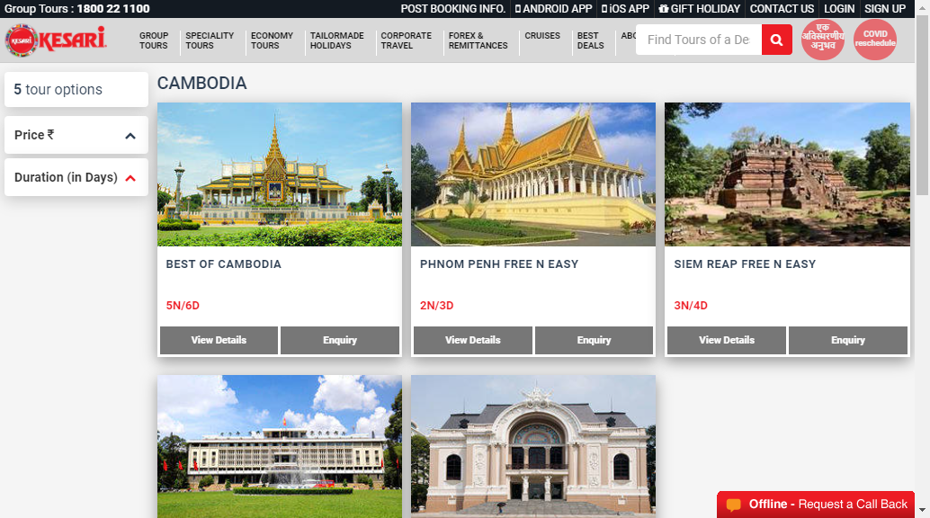

|  |
| --- |
| **TC94 :- To check the functionality of View Details button in BEST OF COMBODIA submodule.** |

w.findElement(By.*xpath*("//*[@id=\"fit\"]/div/div/div[1]/article/div[2]/div[2]/a[1]")).click();

Thread.*sleep*(4000);

w.findElement(By.*xpath*("//*[@id=\"main\"]/div/div[2]/div/div[1]/button")).click();

Thread.*sleep*(5000);

//Enquiry

w.findElement(By.*xpath*("//body/div[9]/div[1]/div[1]/div[1]/div[1]/button[1]")).click();

System.***out***.println("Enquiry of Best of Combodia has been submited.");

Thread.*sleep*(5000);

w.navigate().back();

//View the Details of BEST OF COMBODIA and back to COMBODIA submodule page.

|  |
| --- |
| **TC95:- Check for ALBANIA submodule in EUROPE package.** |

//Europe ......Albania

Actions a3=**new** Actions(w);

WebElement wb3=w.findElement(By.*cssSelector*("div.ng-scope:nth-child(2) header.navbar-static-top.ng-scope:nth-child(2) div.topnav.custom-topnav.hidden-xs.hidden-sm div.container nav.hidden-xs.hidden-sm ul.menu.list-unstyled.mb-0 li.megamenu-menu.tailor-made:nth-child(4) > a.text-uppercase"));

a3.moveToElement(wb3).click().build().perform();

Thread.*sleep*(3000);

w.findElement(By.*xpath*("//*[@id=\"tailor-made-holidays\"]/div/div/div[3]/ul/li[1]/ul/li[1]/a")).click();

Thread.*sleep*(5000);

w.findElement(By.*xpath*("//v-pane-header")).click();

System.***out***.println("EUROPE ALBANIA Package are coming soon..........");

//ALLBANIA tour package open successfully.

//Click on Price V pane Header.

//Package is coming soon….

|  |
| --- |
| **TC96:- Check for AUSTRALIA submodule PACIFIC package.** |

Actions a4=**new** Actions(w);

WebElement wb4=w.findElement(By.*cssSelector*("div.ng-scope:nth-child(2) header.navbar-static-top.ng-scope:nth-child(2) div.topnav.custom-topnav.hidden-xs.hidden-sm div.container nav.hidden-xs.hidden-sm ul.menu.list-unstyled.mb-0 li.megamenu-menu.tailor-made:nth-child(4) > a.text-uppercase"));

a4.moveToElement(wb4).click().build().perform();

Thread.*sleep*(3000);

w.findElement(By.*xpath*("//*[@id=\"tailor-made-holidays\"]/div/div/div[4]/ul/li[1]/ul/li[1]/a")).click();

Thread.*sleep*(5000);

w.findElement(By.*xpath*("//v-pane-header")).click();

Thread.*sleep*(3000);

//Visit to AUSTRALIA package and clicking on Price and Duration V pane Headers .

|  |
| --- |
| **TC99:Take screenshot of AUSTRALIA TOURS** |

TakesScreenshot t1=(TakesScreenshot) w;

File src1=t1.getScreenshotAs(OutputType.***FILE***);

Files.*copy*(src1, **new** File("C:\\Users\\mhatr\\Desktop\\screenshot\\Auustl.png"));

Thread.*sleep*(5000);

System.***out***.println("Welcome To AUSTRALIA Tours ");

//Take SCREENSHOT OF AUSTRALIA package.

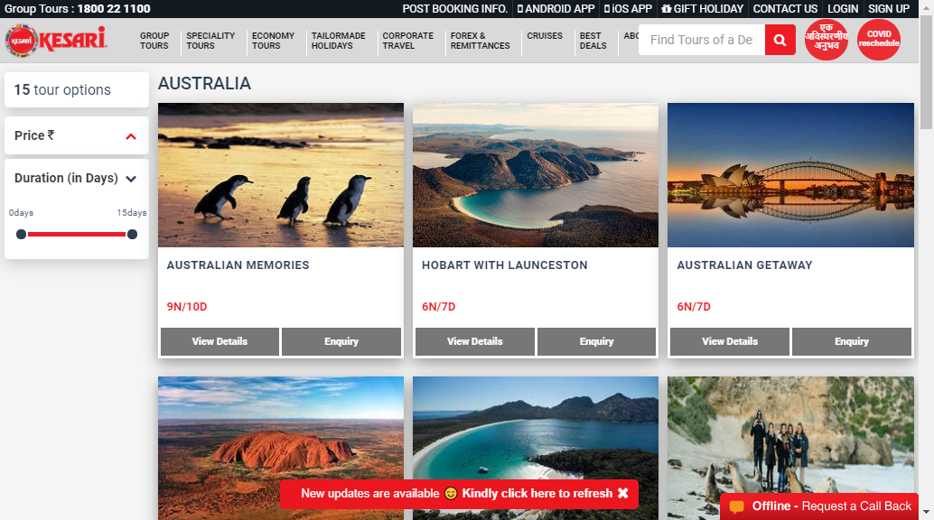

|  |
| --- |
| **TC98:- Check the details of AUSTRALIAN MEMORIES package.** |

w.findElement(By.*xpath*("//*[@id=\"fit\"]/div/div/div[1]/article/div[2]/div[2]/a[1]")).click();

Thread.*sleep*(5000);

w.navigate().back();

//View the Details of of AUSTRALIAN MEMORIES package.

|  |
| --- |
| **TC99:-To test the CORPORATE TRAVEL module** |

//corporate travel

w.findElement(By.xpath("//*[@id=\"main-menu\"]/ul/li[5]/a")).click();

System.out.println(w.getCurrentUrl());

System.***out***.println(w.getTitle());

//window handling

Set<String> windows=w.getWindowHandles();

Iterator <String> it=windows.iterator();

String parent_windows=it.next();

String child_windows=it.next();

w.switchTo().window(child_windows);

Thread.*sleep*(2000);

// the corporate module successfully opened

//URL is https://www.kesari.in/

// Title World Class Travel Company:Group Tours|Speciality Tours

|  |
| --- |
| **TC100:-To test the send button for Corporate Tours Inquiry from home submodule in CORPORATE TRAVEL module.** |

//Home

System.***out***.println("Home");

System.***out***.println(w.getCurrentUrl());

System.***out***.println("Corporate Tours Inquiry");

//Corporate Tours Inquiry deatils

System.out.println("Corporate Tours Inquiry");

w.findElement(By.name("fname_kmice")).sendKeys("Priya");

w.findElement(By.name("email_kmice")).sendKeys("xyz1@gmail.com");

w.findElement(By.name("ctc_no_kmice")).sendKeys("9752486133");

w.findElement(By.name("compNM")).sendKeys("ABC");

w.findElement(By.name("cityNM_kmice")).sendKeys("Mumbai");

w.findElement(By.name("Destination_kmice")).sendKeys("US");

w.findElement(By.name("purpose")).click();

Select s=new Select(w.findElement(By.name("purpose")));

s.selectByIndex(0);

w.findElement(By.name("trDate_kmice")).click();

Select s1=new Select(w.findElement(By.name("trDate_kmice")));

s1.selectByIndex(3);

//send to kesari travel

System.out.println(" Name: Priya");

System.out.println(" Email :xyz1@gmail.com");

System.out.println(" Mobile :9752486133");

System.out.println(" Company Name :ABC");

System.out.println(" City Mumbai");

System.out.println(" Destination : US");

System.out.println("Prpose :Meeting");

System.out.println(" Trvael Date: August");

// successfully test all function and Send data to kresari expert

|  |
| --- |
| **TC101:-Screenshot for CORPORATE TRAVEL module page** |

//screenshot

TakesScreenshot t=(TakesScreenshot) w;

File src =t.getScreenshotAs(OutputType.FILE); // captured the ss

Files.copy(src, new File("D:\\screenshot\\ct.png"));

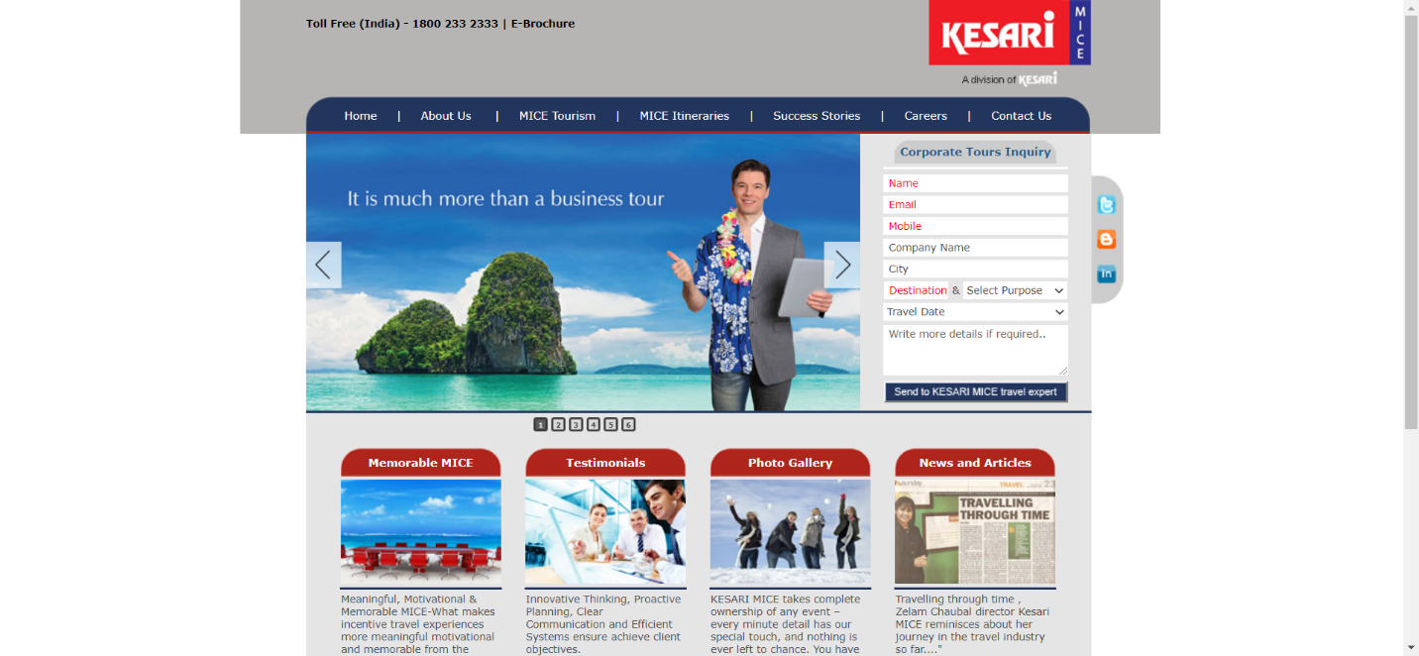

|  |
| --- |
| **TC102:- To test the About Us submodule** |

w.findElement(By.linkText("About Us")).click();

System.out.println("About Us");

System.out.println(w.getCurrentUrl());

System.out.println(w.getTitle());

//Successfully opened and checked the About Us submodule

//Current URL :- <http://www.kesarimice.in/About-us.asp>

//Title Corporate Travel Management:Corporate Travel Management Agency

|  |
| --- |
| **TC103:-To test the kesari function of about us submodule** |

//kesari mice

w.findElement(By.xpath("/html/body/table/tbody/tr[4]/td[2]/table/tbody/tr[3]/td/a/strong")).click();

System.***out***.println("Kesari mice");

//successfully checked on kesari mice function

|  |
| --- |
| **TC104:To check the kesari mice list function of about us submodule** |

//kesari mice list

w.findElement(By.xpath("/html/body/table/tbody/tr[4]/td[2]/table/tbody/tr/td[1]/table/tbody/tr[7]/td/a/strong")).click();

System.out.println("kesari mice list");

// Successfully checked kesari mice list function .

|  |
| --- |
| **TC105:-To test the Mice Tourism submodule** |

w.findElement(By.xpath("/html/body/table/tbody/tr[1]/td[2]/table[2]/tbody/tr/td[2]/a[3]")).click();

System.out.println("Mice Tourism");

System.out.println(w.getCurrentUrl());

System.out.println(w.getTitle());

// Mice Tourism submodule successfully opened

//Current URL :- http://www.kesarimice.in/Mice-Tourism.asp

// Title :- Corporate Tournaments:Corporate tournaments Organizer

|  |
| --- |
| **TC106:- To check the meetings function of Mice Tourism submodule** |

//meetings

w.findElement(By.xpath("/html/body/table/tbody/tr[4]/td[2]/table/tbody/tr/td[1]/table/tbody/tr[3]/td/a/strong")).click();

System.out.println("Meetings");

Thread.sleep(2000);

//Successfully checked the meetings function

|  |
| --- |
| **TC107:-To check the conferences function of Mice Tourism submodule** |

//confrences

w.findElement(By.xpath("/html/body/table/tbody/tr[4]/td[2]/table/tbody/tr/td[1]/table/tbody/tr[7]/td/a/strong")).click();

System.***out***.println("Conferences/Conventions");

//successfully checked the conferences function

|  |
| --- |
| **TC108:-To check the function of Mice Tourism submodule** |

//exhibitions

w.findElement(By.xpath("/html/body/table/tbody/tr[4]/td[2]/table/tbody/tr/td[1]/table/tbody/tr[9]/td/a/strong")).click();

System.out.println("Exhibitions");

//successfully checked the Exhibitions function

|  |
| --- |
| **TC109:-To test the MICE Intineraries submodule** |

// MICE Itineraries

w.findElement(By.*linkText*("MICE Itineraries")).click();

System.***out***.println(" MICE Itineraries ");

System.***out***.println(w.getCurrentUrl());

System.***out***.println(w.getTitle());

//MICE Intineraries submodule successfully opened

|  |
| --- |
| **TC110:-To check the INDIA function of MICE Intineraries submodule** |

//INDIA

w.findElement(By.*xpath*("/html/body/table/tbody/tr[4]/td[2]/table/tbody/tr[1]/td[2]/table/tbody/tr[1]/td/a/strong")).click();

System.***out***.println("INDIA");

System.***out***.println(w.getCurrentUrl());

Thread.*sleep*(2000);

//successfully checked the INDIA function

|  |
| --- |
| **TC111:-To check the Hydrabad subfunction of INDIA** |

//Hydrabad

w.findElement(By.*xpath*("/html/body/table/tbody/tr[4]/td[2]/table/tbody/tr[2]/td[3]/table/tbody/tr[2]/td[1]/a/strong")).click();

System.***out***.println("Hydrabad");

Thread.*sleep*(3000);

System.***out***.println(w.getCurrentUrl());

Thread.*sleep*(3000);

w.navigate().back();

Thread.*sleep*(4000);

//successfully checked the Hydrabad subfunction

|  |
| --- |
| TC112:-To check the Jaipur subfunction of INDIA |

//Jaipur

w.findElement(By.*xpath*("/html/body/table/tbody/tr[4]/td[2]/table/tbody/tr[2]/td[3]/table/tbody/tr[2]/td[5]")).click();

System.***out***.println("Jaipur");

Thread.*sleep*(3000);

System.***out***.println(w.getCurrentUrl());

w.navigate().back();

Thread.*sleep*(4000);

//successfully checked the Jaipur subfunction

|  |
| --- |
| **TC113:-To check the Goa subfunction of INDIA** |

//Goa

w.findElement(By.*xpath*("/html/body/table/tbody/tr[4]/td[2]/table/tbody/tr[2]/td[3]/table/tbody/tr[5]/td[1]/a/img")).click();

System.***out***.println("Goa");

System.***out***.println(w.getCurrentUrl());

Thread.*sleep*(3000);

w.navigate().back();

Thread.*sleep*(4000);

//successfully checked the Goa subfunction

|  |
| --- |
| **TC114:-To check the Mysore subfunction of INDIA** |

//Mysore

w.findElement(By.*xpath*("/html/body/table/tbody/tr[4]/td[2]/table/tbody/tr[2]/td[3]/table/tbody/tr[5]/td[5]/a/img")).click();

System.***out***.println("Mysore");

System.***out***.println(w.getCurrentUrl());

Thread.*sleep*(3000);

w.navigate().back();

Thread.*sleep*(4000);

//successfully checked the Mysore subfunction

|  |
| --- |
| **TC115:-To check the Nainital subfunction of INDIA** |

//Nainital

w.findElement(By.*xpath*("/html/body/table/tbody/tr[4]/td[2]/table/tbody/tr[2]/td[3]/table/tbody/tr[10]/td[1]")).click();

System.***out***.println("Nainital");

System.***out***.println(w.getCurrentUrl());

Thread.*sleep*(3000);

w.navigate().back();

Thread.*sleep*(4000);

//successfully checked the Nainital subfunction

|  |
| --- |
| **TC116:-To check the Mahabaleshwar subfunction of INDIA** |

//Mahabaleshwar

w.findElement(By.*xpath*("/html/body/table/tbody/tr[4]/td[2]/table/tbody/tr[2]/td[3]/table/tbody/tr[10]/td[7]")).click();

System.***out***.println("Mahabaleshwar");

System.***out***.println(w.getCurrentUrl());

Thread.*sleep*(3000);

w.navigate().back();

Thread.*sleep*(4000);

//successfully checked the Mahabaleshwar subfunction

|  |
| --- |
| **TC117:-Take screenshot of MICE Intineraries submodule functions** |

// screenshot

TakesScreenshot t1=(TakesScreenshot) w;

File src1 =t1.getScreenshotAs(OutputType.***FILE***);

Files.*copy*(src1, **new** File("D:\\screenshot\\mice.png"));

Thread.*sleep*(2000);

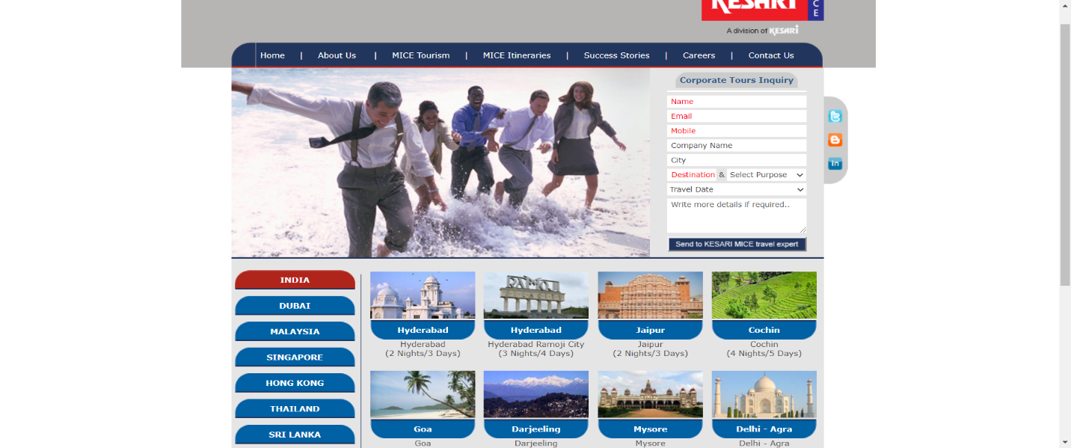

|  |
| --- |
| **TC118:_To test DUBAI function of MICE Intineraries submodule** |

//DUBAI

w.findElement(By.*xpath*("/html/body/table/tbody/tr[4]/td[2]/table/tbody/tr[2]/td[1]/table/tbody/tr[3]/td")).click();

System.***out***.println("DUBAI");

Thread.*sleep*(3000);

System.***out***.println(w.getCurrentUrl());

Thread.*sleep*(4000);

//DUBAI function successfully opened

|  |
| --- |
| **TC119:-To check Dubai:-Conference Tour subfunction of DUBAI** |

//Dubai:Conference Tour

w.findElement(By.*xpath*("/html/body/table/tbody/tr[4]/td[2]/table/tbody/tr[2]/td[3]/table/tbody/tr[2]/td[1]")).click();

Thread.*sleep*(3000);

w.navigate().back();

Thread.*sleep*(4000);

//successfully checked Dubai:Conference function

|  |
| --- |
| **TC120:-To check Dubai:Maharashtra Udyog Jatra subfunction of DUBAI** |

//Dubai:Maharashtra Udyog Jatra  [(2 Nights/3 Days)](http://www.kesarimice.in/Dubai-creative1.asp)

w.findElement(By.*xpath*("/html/body/table/tbody/tr[4]/td[2]/table/tbody/tr[2]/td[3]/table/tbody/tr[2]/td[5]")).click();

System.***out***.println(w.getCurrentUrl());

Thread.*sleep*(3000);

w.navigate().back();

Thread.*sleep*(4000);

//successfully checked Dubai:Maharashtra Udyog Jatra function

|  |
| --- |
| **TC121:-To check Dubai:Maharashtra Udyog Jatra function** |

//Dubai: Maharashtra Udyog Jatra  [(4 Nights/5 Days)](http://www.kesarimice.in/Dubai-creative3.asp)

w.findElement(By.*xpath*("/html/body/table/tbody/tr[4]/td[2]/table/tbody/tr[2]/td[3]/table/tbody/tr[6]/td")).click();

System.***out***.println(w.getCurrentUrl());

Thread.*sleep*(3000);

w.navigate().back();

Thread.*sleep*(4000);

//successfully checked Dubai:Maharashtra Udyog Jatra

|  |
| --- |
| **TC122:-To test SINGAPORE function of MICE Intineraries submodule** |

//SINGAPORE

w.findElement(By.*xpath*("/html/body/table/tbody/tr[4]/td[2]/table/tbody/tr[2]/td[1]/table/tbody/tr[7]/td")).click();

System.***out***.println("SINGAPORE");

System.***out***.println(w.getCurrentUrl());

Thread.*sleep*(3000);

//SINGAPUR function successfully opened

|  |
| --- |
| **TC123:To check Singapore:Conference subfunction of SINGAPORE** |

//Singapore : Conference

w.findElement(By.*xpath*("/html/body/table/tbody/tr[4]/td[2]/table/tbody/tr[2]/td[3]/table/tbody/tr[2]/td[1]")).click();

System.***out***.println("Singapore : Conference ");

System.***out***.println(w.getCurrentUrl());

Thread.*sleep*(3000);

w.navigate().back();

Thread.*sleep*(3000);

//successfully checked Singapore:-Conference subfunction

|  |
| --- |
| **TC124:-To test THAILAND function of MICE Intineraries submodule** |

//THAILAND

w.findElement(By.*xpath*("/html/body/table/tbody/tr[4]/td[2]/table/tbody/tr[2]/td[1]/table/tbody/tr[11]/td")).click();

System.***out***.println("THAILAND");

System.***out***.println(w.getCurrentUrl());

Thread.*sleep*(3000);

// Thailand function successfully opened

|  |
| --- |
| **TC125:-To test SWITZERLAND function MICE Intineraries submodule** |

//SWITZERLAND

w.findElement(By.*xpath*("/html/body/table/tbody/tr[4]/td[2]/table/tbody/tr[2]/td[1]/table/tbody/tr[15]/td")).click();

System.***out***.println("SWITZERLAND");

System.***out***.println(w.getCurrentUrl());

Thread.*sleep*(3000);

System.***out***.println(w.getTitle());

Thread.*sleep*(3000);

// Switzerland function successfully opened

|  |
| --- |
| **TC126:-To test Success Stories submodule** |

//success stories

w.findElement(By.*linkText*("Success Stories")).click();

System.***out***.println("Sucess Stories");

System.***out***.println(w.getCurrentUrl());

Thread.*sleep*(3000);

System.***out***.println(w.getTitle());

Thread.*sleep*(3000);

// Success Stories submodule successfully opened

|  |
| --- |
| **TC127:To check Special Needs function of Success stories** |

//special needs

w.findElement(By.*xpath*("/html/body/table/tbody/tr[4]/td[2]/table/tbody/tr[5]/td")).click();

System.***out***.println("Special needs");

Thread.*sleep*(3000);

//successfully checked special needs function

|  |
| --- |
| **TC128:-To test Careers function** |

//careers

w.findElement(By.*linkText*("Careers")).click();

System.***out***.println("Careers");

System.***out***.println(w.getCurrentUrl());

System.***out***.println(w.getTitle());

Thread.*sleep*(2000);

//Carees function successfully opened

|  |
| --- |
| **TC129:-To test Contact submodule** |

//contact

w.findElement(By.*linkText*("Contact Us")).click();

System.***out***.println("Contact us");

System.***out***.println(w.getCurrentUrl());

System.***out***.println(w.getTitle());

Thread.*sleep*(2000);

w.findElement(By.*name*("full_nm")).sendKeys("Siya");

w.findElement(By.*name*("Compname")).sendKeys("DJK");

w.findElement(By.*name*("MobileN")).sendKeys("8655489725");

w.findElement(By.*name*("purpose")).click();

Select s2=**new** Select(w.findElement(By.*name*("purpose")));

s2.selectByIndex(1);

w.findElement(By.*name*("Dest")).sendKeys("UK");

w.findElement(By.*name*("trMonth")).click();

Select s3=**new** Select(w.findElement(By.*name*("trMonth")));

s3.selectByIndex(3);

w.findElement(By.*name*("trYr")).click();

Select s4=**new** Select(w.findElement(By.*name*("trYr")));

s4.selectByIndex(2);

w.findElement(By.*name*("DaysN")).sendKeys("5");

w.findElement(By.*name*("PaxN")).sendKeys("2");

w.findElement(By.*name*("comments")).sendKeys("Nothing");

//submit

Thread.*sleep*(2000);

//Contact module successfully opened

|  |
| --- |
| **TC130:-To test branches function of contact submodule** |

//branches

w.findElement(By.*linkText*("Branch Offices")).click();

System.***out***.println("Branch Offices");

Thread.*sleep*(2000);

// branches function successfully opened

|  |
| --- |
| **TC131:-Take a screenshot of branches function** |

TakesScreenshot t2=(TakesScreenshot) w;

File src2 =t2.getScreenshotAs(OutputType.***FILE***);

Files.*copy*(src2, **new** File("D:\\screenshot\\branch.png"));

Thread.*sleep*(2000);

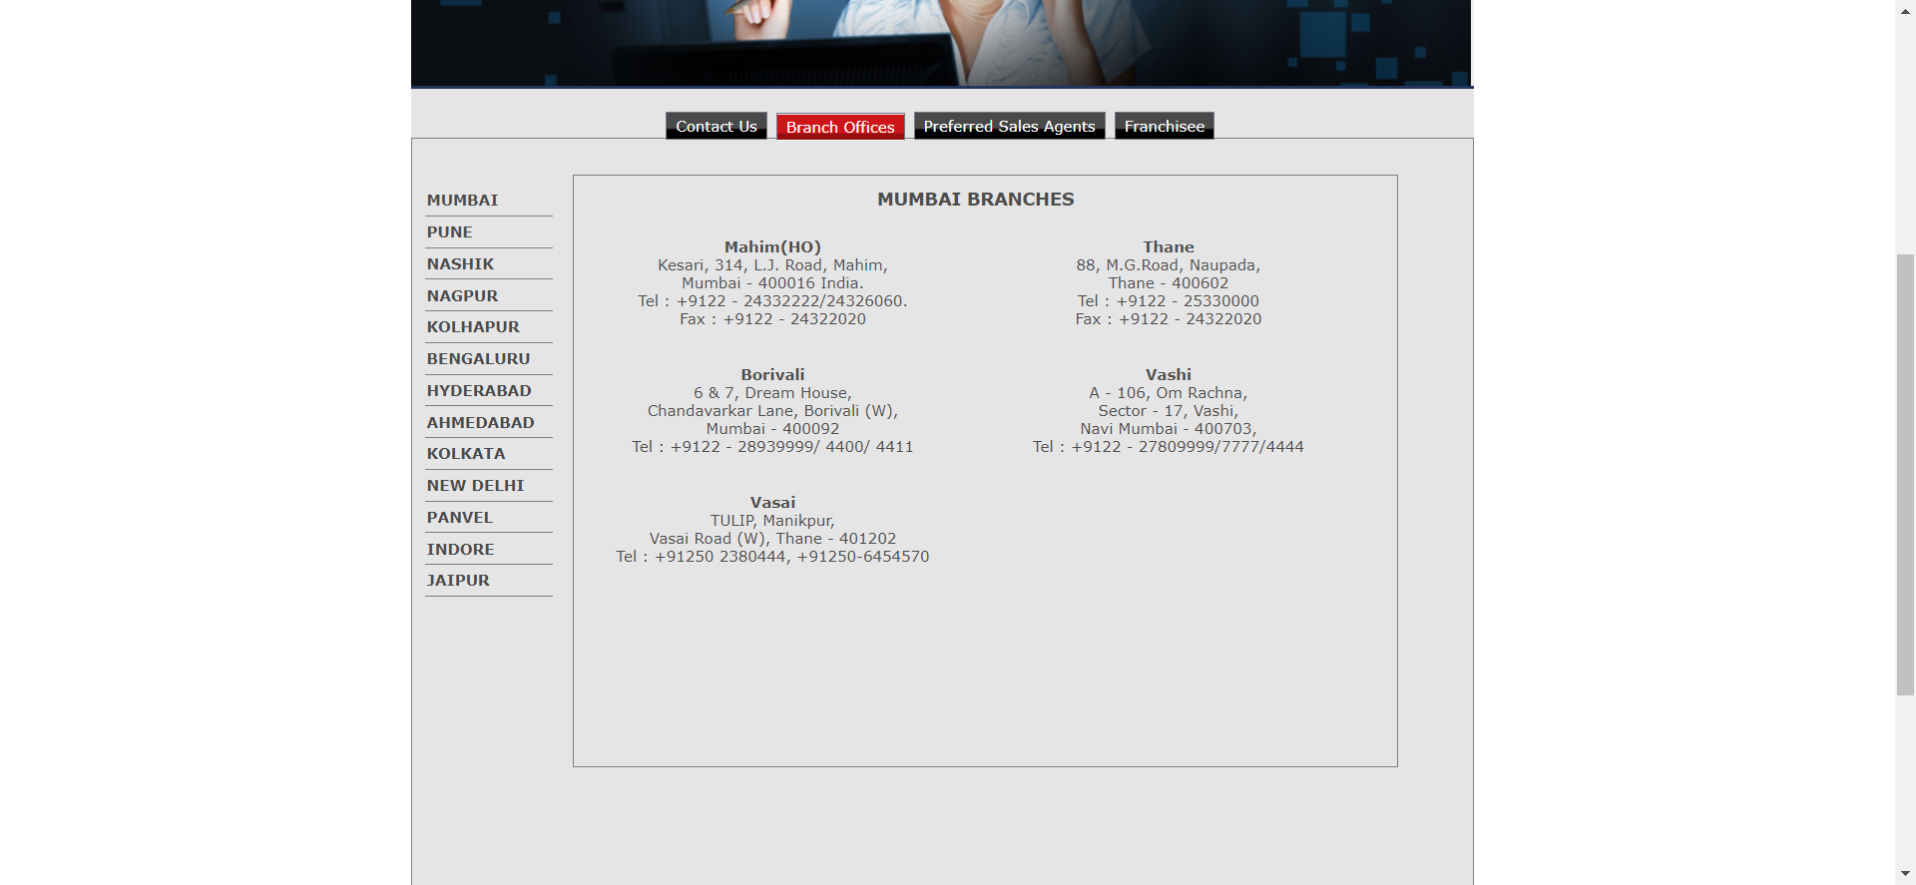

|  |
| --- |
| **TC132:-To test Preferred sales Agents function of contact** |

// Preferred Sales Agents

w.findElement(By.*linkText*("Preferred Sales Agents")).click();

System.***out***.println(" Preferred Sales Agents");

Thread.*sleep*(2000);

// Preferred sales agents function successfully opened

|  |
| --- |
| **TC133:-To test Franchisee function of contact and back to homepage** |

//franchise

w.findElement(By.*linkText*("Franchisee")).click();

System.***out***.println("Franchisse");

Thread.*sleep*(2000);

// franchisee function successfully opened

|  |
| --- |
| **TC134:-To back to home page** |

w.switchTo().window(parent_windows);

Thread.*sleep*(2000);

//successfully back to homepage

|  |
| --- |
| **TC135:-To test FOREX AND REMITTANCES module** |

//Open FOREX & REMITTANCES

w.findElement(By.*xpath*("//*[@id=\"main-menu\"]/ul/li[6]/a")).click();

System.***out***.println(" FOREX & REMITTANCES");

Thread.*sleep*(2000);

System.***out***.println(w.getCurrentUrl());

//successfully opened the FOREX AND REMITTANCES

|  |
| --- |
| **TC140:-To check the functionality of Forex and Remittances module** |

//Enquiries //

w.findElement(By.*name*("name")).sendKeys("Riya");

w.findElement(By.*name*("mobileNumber")).sendKeys("9945826472");

w.findElement(By.*name*("email")).sendKeys("riya12@gmai.com");

w.findElement(By.*name*("purposeOfTravel")).click();

Select s5=**new** Select(w.findElement(By.*name*("purposeOfTravel")));

s5.selectByVisibleText("Studies");

w.findElement(By.*id*("destination")).sendKeys("London");

w.findElement(By.*name*("products")).click();

Select s6=**new** Select( w.findElement(By.*name*("products")));

Thread.*sleep*(1000);

s6.selectByVisibleText("Travel Insurance");

w.findElement(By.*xpath*("//*[@id=\"content\"]/div/div[1]/div[2]/div/form/div[7]/div/label")).click();

//print

System.***out***.println("Name : Riya");

System.***out***.println("Mobile Number :9945826472");

System.***out***.println("Emai : riya12@gmai.com");

System.***out***.println("Purpose of Travel : Studies");

System.***out***.println("Destination : London");

System.***out***.println(" Products : Travel Insurance");

//successfully check all function of forex ans Remittances module

|  |
| --- |
| **TC141:-To check product and offering functionality of Forex and Remittances module** |

//Our Products & Offerings//

System.***out***.println("Our Products & Offerings");

w.findElement(By.*xpath*("//*[@id=\"content\"]/div/div[3]/div/div/ul/li[1]/div")).click();

System.***out***.println("FOREX CARD");

Thread.*sleep*(1000);

w.findElement(By.*xpath*("//*[@id=\"content\"]/div/div[3]/div/div/ul/li[2]/div")).click();

System.***out***.println("TRAVELLER CHEQUES");

Thread.*sleep*(1000);

w.findElement(By.*xpath*("//*[@id=\"content\"]/div/div[3]/div/div/ul/li[3]/div")).click();

System.***out***.println("CURRENCY NOTES");

Thread.*sleep*(1000);

w.findElement(By.*xpath*("//*[@id=\"content\"]/div/div[3]/div/div/ul/li[4]/div")).click();

System.***out***.println("MONEY TRANSFER");

Thread.*sleep*(1000);

w.findElement(By.*xpath*("//*[@id=\"content\"]/div/div[3]/div/div/ul/li[5]/div")).click();

System.***out***.println("TRAVEL INSURANCE");

Thread.*sleep*(1000);

//successfully checked the function

|  |
| --- |
| **TC142:To check multi purpose functionality of Forex and Remittances** |

// Check Multi-purpose Remittance Solutions

System.***out***.println("Multi-purpose Remittance Solutions");

w.findElement(By.*xpath*("//*[@id=\"content\"]/div/div[4]/div/div/ul/li[1]/div")).click();

System.***out***.println("TRAVEL ABROAD");

Thread.*sleep*(1000);

w.findElement(By.*xpath*("//*[@id=\"content\"]/div/div[4]/div/div/ul/li[2]/div")).click();

System.***out***.println("OVERSEAS EDUCATION");

Thread.*sleep*(1000);

w.findElement(By.*xpath*("//*[@id=\"content\"]/div/div[4]/div/div/ul/li[3]/div")).click();

System.***out***.println("MEDICAL TREATMENT");

Thread.*sleep*(1000);

w.findElement(By.*xpath*("//*[@id=\"content\"]/div/div[4]/div/div/ul/li[4]/div")).click();

System.***out***.println("CONFERENCES AND SEMINARS");

Thread.*sleep*(2000);

//successfully checked the functions

|  |
| --- |
| **TC143:-To test the CRUSIES module** |

//Open CRUSIES module

w.findElement(By.*xpath*("//*[@id=\"main-menu\"]/ul/li[7]/a")).click();

Thread.*sleep*(2000);

System.***out***.println(w.getCurrentUrl());

Thread.*sleep*(2000);

System.***out***.println(w.getTitle());

Thread.*sleep*(2000);

//successfully opened CRUSIES module

|  |
| --- |
| **TC144:-Take screenshot of CRUSIES module** |

TakesScreenshot t3=(TakesScreenshot) w;

File src3 =t3.getScreenshotAs(OutputType.***FILE***); // captured the ss

Files.*copy*(src3, **new** File("D:\\screenshot\\c.png"));

|  |
| --- |
| **TC145:_Take screenshot of CRUSISES module page** |

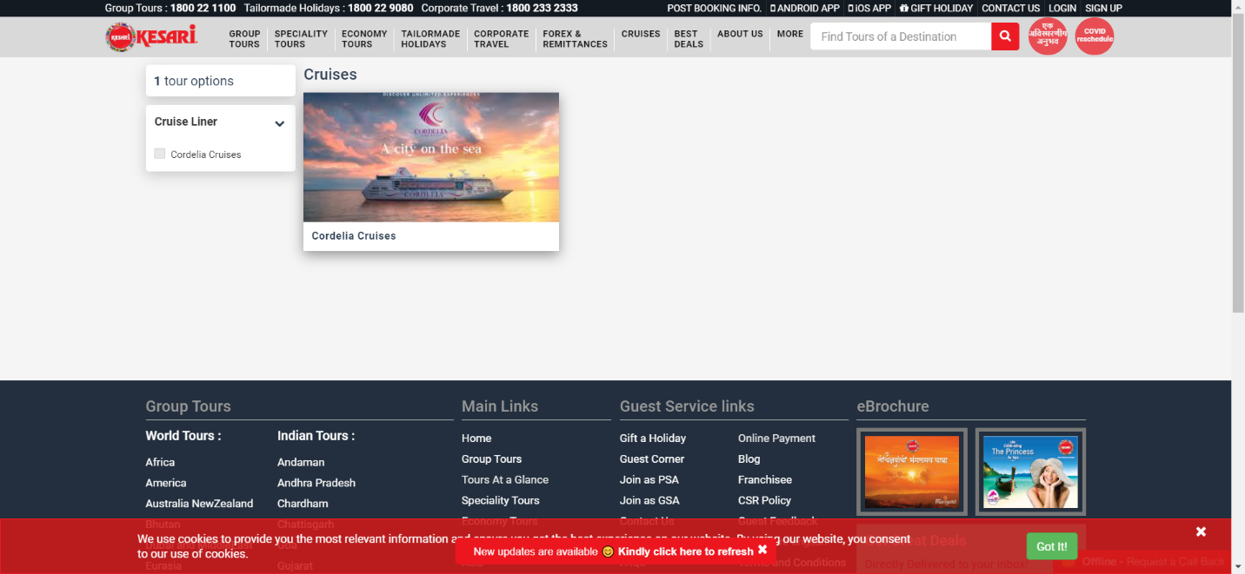

|  |
| --- |
| **TC146:-To test the Cordelia Crusies submodule** |

// Cordelia Crusies

w.findElement(By.*xpath*("//*[@id=\"main\"]/div/div[1]/v-accordion/v-pane/v-pane-content")).click();

System.***out***.println("Cordelia Crusies");

Thread.*sleep*(2000);

System.***out***.println(w.getCurrentUrl());

System.***out***.println(w.getTitle());

Thread.*sleep*(2000);

//Cordelia Crusies submodule successfully opened

|  |
| --- |
| **TC147:-Take screenshot of Cordelia Crusies submodule** |

//screenshot

TakesScreenshot t4=(TakesScreenshot) w;

File src4 =t4.getScreenshotAs(OutputType.***FILE***); // captured the ss

Files.*copy*(src4, **new** File("D:\\screenshot\\CC.png"));

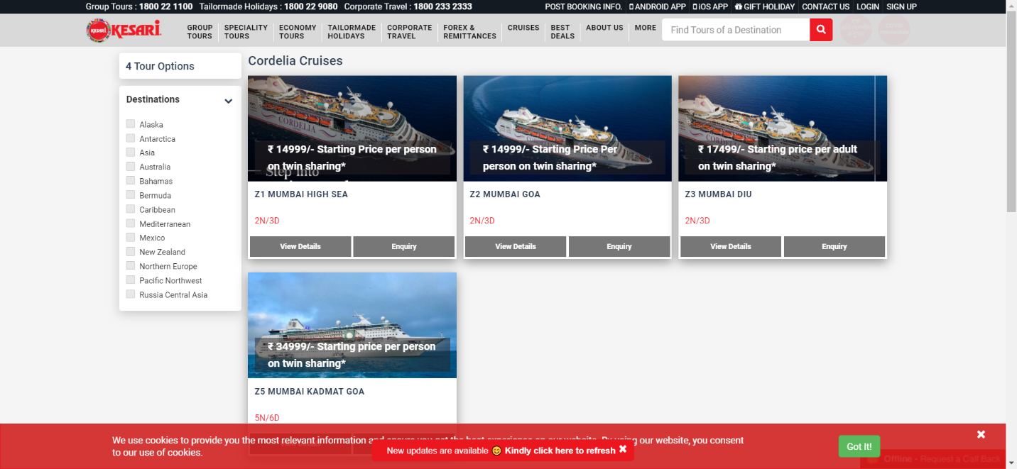

|  |
| --- |
| **TC148:-To test Mumbai High sea function** |

// view details= Mumbai High Sea

Thread.*sleep*(2000);

w.findElement(By.*linkText*("View Details")).click();

System.***out***.println("Mumbai High Sea");

Thread.*sleep*(2000);

System.***out***.println(w.getCurrentUrl());

Thread.*sleep*(2000);

System.***out***.println(w.getTitle());

Thread.*sleep*(2000);

System.***out***.println("View Details");

Thread.*sleep*(2000);

System.***out***.println(w.getCurrentUrl());

Thread.*sleep*(2000);

System.***out***.println(w.getTitle());

Thread.*sleep*(2000);

System.***out***.println("View Details");

Thread.*sleep*(2000);

// scroll

JavascriptExecutor js1=(JavascriptExecutor) w;

Thread.*sleep*(3000);

js1.executeScript("window.scrollBy(0,2000)");

Thread.*sleep*(2000);

js1.executeScript("window.scrollBy(0,-2000)");

Thread.*sleep*(2000);

//Inclusion/Exclusion

w.findElement(By.*xpath*("//*[@id=\"main\"]/div[2]/div/div/div/ul/li[2]/a")).click();

System.***out***.println("Inclusion/Exclusion");

Thread.*sleep*(2000);

//FAQ

//w.findElement(By.linkText("FAQ's")).click();

w.findElement(By.*xpath*("//*[@id=\"main\"]/div[2]/div/div/div/ul/li[3]/a")).click();

System.***out***.println("FAQ");

//option select 1

w.findElement(By.*cssSelector*("div.ng-scope:nth-child(3) section.ng-scope:nth-child(3) div.container div.row div.col-xs-12 div.nav-tabs-custom.nav-tabs-custom--cruise div.ng-isolate-scope div.tab-content div.tab-pane.ng-scope.active:nth-child(2) div.toggle-container.toggle-container--style-1.ng-scope div.panel:nth-child(1) h4.panel-title > a.collapsed")).click();

Thread.*sleep*(2000);

w.findElement(By.*xpath*("//*[@id=\"faq\"]/div[1]/h4/a")).click();

//w.navigate().back();

Thread.*sleep*(2000);

//2

w.findElement(By.*cssSelector*("div.ng-scope:nth-child(3) section.ng-scope:nth-child(3) div.container div.row div.col-xs-12 div.nav-tabs-custom.nav-tabs-custom--cruise div.ng-isolate-scope div.tab-content div.tab-pane.ng-scope.active:nth-child(2) div.toggle-container.toggle-container--style-1.ng-scope div.panel:nth-child(2) h4.panel-title > a.collapsed")).click();

Thread.*sleep*(2000);

w.findElement(By.*xpath*("//*[@id=\"faq\"]/div[2]/h4/a")).click();

Thread.*sleep*(2000);

w.navigate().back();

Thread.*sleep*(2000);

//successfully test Mumbai High sea Function

|  |
| --- |
| **TC149:-To test the Enquiry function of Mumbai High Sea** |

//enquiry

w.findElement(By.*linkText*("Enquiry")).click();

System.***out***.println("Enquiry");

Thread.*sleep*(2000);

//cross sign

w.findElement(By.*xpath*("//*[@id=\"container\"]/div[1]/button")).click();

Thread.*sleep*(2000);

//successfully tested inquiry function

|  |
| --- |
| **TC150:-To test Mumbai Goa function** |

//view details=Mumbai Goa

w.findElement(By.*xpath*("//*[@id=\"main\"]/div/div[2]/div/div/div[2]/article/figure/div[2]/div[2]/a[1]")).click();

System.***out***.println("Mumbai Goa");

Thread.*sleep*(2000);

System.***out***.println(w.getCurrentUrl());

Thread.*sleep*(2000);

System.***out***.println(w.getTitle());

Thread.*sleep*(2000);

System.***out***.println("View Details");

Thread.*sleep*(2000);

//scroll

JavascriptExecutor js2=(JavascriptExecutor) w;

Thread.*sleep*(3000);

js2.executeScript("window.scrollBy(0,2000)");

Thread.*sleep*(2000);

js2.executeScript("window.scrollBy(0,-2000)");

Thread.*sleep*(2000);

//enquiry

w.findElement(By.*xpath*("//*[@id=\"main\"]/div[1]/div/div[3]/button")).click();

System.***out***.println("Enquiry");

Thread.*sleep*(2000);

//cross sign

w.findElement(By.*xpath*("//*[@id=\"container\"]/div[1]/button")).click();

Thread.*sleep*(2000);

//Inclusion /Exclusion

w.findElement(By.*xpath*("//*[@id=\"main\"]/div[2]/div/div/div/ul/li[2]/a")).click();

System.***out***.println("Inclusion /Exclusion");

Thread.*sleep*(2000);

//FAQ

w.findElement(By.*xpath*("//*[@id=\"main\"]/div[2]/div/div/div/ul/li[3]/a")).click();

System.***out***.println("FAQ");

Thread.*sleep*(2000);

//1

w.findElement(By.*xpath*("//*[@id=\"faq\"]/div[1]/h4/a")).click();

Thread.*sleep*(2000);

w.findElement(By.*xpath*("//*[@id=\"faq\"]/div[1]/h4/a")).click();

Thread.*sleep*(2000);

//w.findElement(By.xpath("//*[@id=\"faq\"]/div[3]/h4/a")).click();

//Thread.sleep(2000);

//w.findElement(By.xpath("//*[@id=\"faq\"]/div[3]/h4/a")).click();

w.navigate().back();

Thread.*sleep*(2000);

//successfully tested the Mumbai Goa function

|  |
| --- |
| **TC151:-To test inquiry function of Mumbai Goa** |

//enquiry

w.findElement(By.*xpath*("//*[@id=\"main\"]/div/div[2]/div/div/div[2]/article/figure/div[2]/div[2]/a[2]")).click();

System.***out***.println("Enquiry");

//cross

w.findElement(By.*xpath*("//*[@id=\"container\"]/div[1]/button")).click();

Thread.*sleep*(2000);

//successfully tested inquiry function

|  |
| --- |
| **TC151:-To test Mumbai Dui function** |

//Mumbai Dui

//details

w.findElement(By.*xpath*("//*[@id=\"main\"]/div/div[2]/div/div/div[3]/article/figure/div[2]/div[2]/a[1]")).click();

System.***out***.println("Mumbai Dui");

Thread.*sleep*(2000);

System.***out***.println(w.getCurrentUrl());

Thread.*sleep*(2000);

System.***out***.println(w.getTitle());

Thread.*sleep*(2000);

System.***out***.println("View Details");

Thread.*sleep*(2000);

//Inclusion/Exclusion

w.findElement(By.*xpath*("//*[@id=\"main\"]/div[2]/div/div/div/ul/li[2]/a")).click();

System.***out***.println("Inclusion/Exclusion");

Thread.*sleep*(2000);

//FAQ

w.findElement(By.*xpath*("//*[@id=\"main\"]/div[2]/div/div/div/ul/li[3]/a")).click();

System.***out***.println("FAQ");

Thread.*sleep*(2000);

w.navigate().back();

Thread.*sleep*(2000);

//successfully tested Mumbai Dui function

|  |
| --- |
| **TC152:-To check inquiry function for Mumbai Dui** |

//enquiry

w.findElement(By.*xpath*("//*[@id=\"main\"]/div/div[2]/div/div/div[3]/article/figure/div[2]/div[2]/a[2]")).click();

System.***out***.println("Enquiry");

Thread.*sleep*(2000);

//cross

w.findElement(By.*xpath*("//*[@id=\"container\"]/div[1]/button")).click();

Thread.*sleep*(2000);

//successfully tested inquiry function

|  |
| --- |
| **TC153:-To test the destination function** |

/checkbox

System.***out***.println("Destinations");

//Antartica

w.findElement(By.*xpath*("//*[@id=\"main\"]/div/div[1]/v-accordion/v-pane/v-pane-content/div/div/ul/li[2]/div/label")).click();

System.***out***.println("Antartica");

Thread.*sleep*(2000);

//Australia

w.findElement(By.*xpath*("//*[@id=\"main\"]/div/div[1]/v-accordion/v-pane/v-pane-

System.***out***.println("Australia");

Thread.*sleep*(2000);

//Caribbean

w.findElement(By.*xpath*("//*[@id=\"main\"]/div/div[1]/v-accordion/v-pane/v-pane-content/div/div/ul/li[7]/div/label")).click();

System.***out***.println("Caribbean");

Thread.*sleep*(2000);

//North Europe

w.findElement(By.*xpath*("//*[@id=\"main\"]/div/div[1]/v-accordion/v-pane/v-pane-content/div/div/ul/li[11]/div/label")).click();

System.***out***.println("North Europe");

Thread.*sleep*(2000);

//Russia Central Asia

w.findElement(By.*xpath*("//*[@id=\"main\"]/div/div[1]/v-accordion/v-pane/v-pane-content/div/div/ul/li[13]/div")).click();

System.***out***.println("Russia Central Asia");

Thread.*sleep*(2000);

//successfully test this destination

|  |
| --- |
| **TC154:-To test the Best Deals module** |

//Best Deals open

w.findElement(By.*xpath*("/html[1]/body[1]/div[2]/header[1]/div[1]/div[2]/nav[1]/ul[1]/li[8]/a[1]")).click();

System.***out***.println("Best Deals");

System.***out***.println(w.getTitle());

Thread.*sleep*(1000);

//successfully opened the Best Deals module

|  |
| --- |
| **TC156:-Take screenshot of Best Deals module** |

//screenshot

TakesScreenshot t5=(TakesScreenshot) w;

File src5 =t5.getScreenshotAs(OutputType.***FILE***);

Files.*copy*(src5, **new** File("D:\\screenshot\\j.png"));

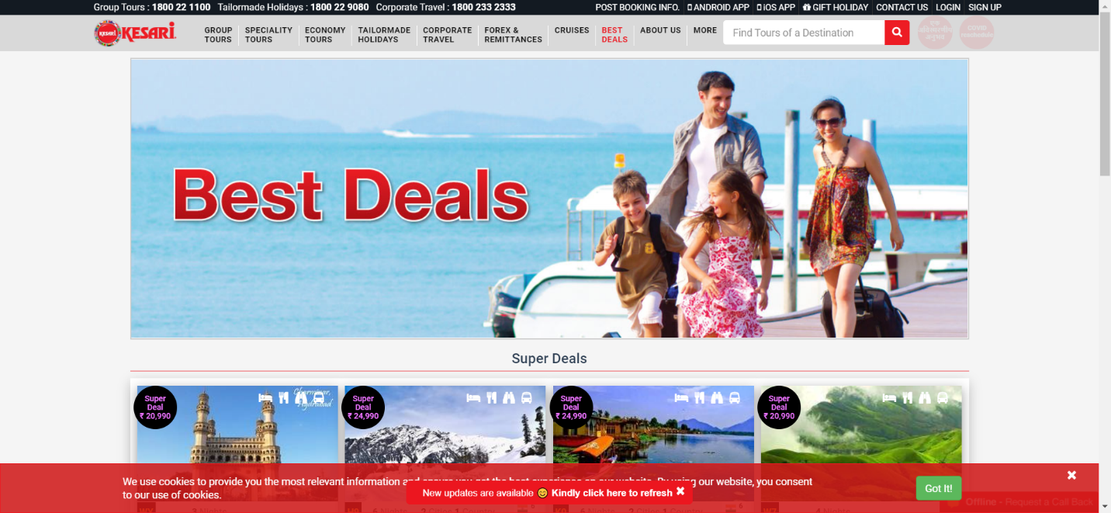

|  |
| --- |
| **TC157:-To test Hyderabad Ramoji function** |

//HYDERABAD RAMOJI open

w.findElement(By.*xpath*("//*[@id=\"main\"]/div/div/div[1]/article/figure/div[2]/a/ul[1]")).click();

System.***out***.println("HYDERABAD RAMOJI ");

System.***out***.println(w.getTitle());

Thread.*sleep*(2000);

//scroll

JavascriptExecutor js3=(JavascriptExecutor) w;

Thread.*sleep*(3000);

js3.executeScript("window.scrollBy(0,2000)");

Thread.*sleep*(4000);

js3.executeScript("window.scrollBy(0,-2000)");

Thread.*sleep*(3000);

//date

w.findElement(By.*xpath*("//*[@id=\"main\"]/div[3]/div[2]/div/div[1]/ul[1]/li[1]/button")).click();

System.***out***.println("AUG");

Thread.*sleep*(2000);

//available seats

w.findElement(By.*xpath*("//*[@id=\"tbody\"]/table/tbody/tr/td[1]/div[2]/p")).click(); System.***out***.println("Available seats");

Thread.*sleep*(2000);

// cross sign for available seats

w.findElement(By.*xpath*("//*[@id=\"room-booking\"]/div/div[1]/button")).click();

Thread.*sleep*(2000);

//Enquiry

w.findElement(By.*xpath*("//*[@id=\"main\"]/div[3]/div[2]/div/div[1]/button[1]")).click();

Thread.*sleep*(2000);

//cross mark

w.findElement(By.*cssSelector*("body.modal-open:nth-child(2) div.modal.ng-isolate-scope.in:nth-child(20) div.modal-dialog.modal-lg div.modal-content div.ng-scope div.modal-header.modal-header--transparent.modal-header--bg > button.close")).click();

Thread.*sleep*(2000);

//tour price

w.findElement(By.*xpath*("//*[@id=\"main\"]/div[3]/div[2]/div/div[1]/button[2]")).click();

System.***out***.println("Tour price");

Thread.*sleep*(2000);

//cross mark

w.findElement(By.*cssSelector*("body.modal-open:nth-child(2) div.modal.ng-isolate-scope.in:nth-child(20) div.modal-dialog.modal-lg div.modal-content div.modal-content.ng-scope div.modal-header > button.close")).click();

//date

w.findElement(By.*xpath*("//*[@id=\"main\"]/div[3]/div[2]/div/div[1]/ul[1]/li[2]/button")).click();

System.***out***.println("SEPT");

Thread.*sleep*(2000);

w.findElement(By.*xpath*("//*[@id=\"main\"]/div[3]/div[2]/div/div[1]/ul[1]/li[3]/button")).click();

System.***out***.println("NOV");

Thread.*sleep*(2000);

w.findElement(By.*xpath*("//*[@id=\"main\"]/div[3]/div[2]/div/div[1]/ul[1]/li[4]/button")).click();

System.***out***.println("DEC");

Thread.*sleep*(2000);

w.navigate().back();

Thread.*sleep*(2000);

//inquiry

w.findElement(By.*xpath*("//*[@id=\"main\"]/div/div/div[1]/article/figure/div[3]/div[2]/a[2]")).click();

System.***out***.println("Inquiry");

Thread.*sleep*(3000);

//cross button

w.findElement(By.*xpath*("//*[@id=\"container\"]/div[1]/button")).click();

Thread.*sleep*(3000);

//successfully tested Hyderabad Ramoji function

|  |
| --- |
| **TC158:-To test Kanyakumari Kovalam function** |

//KANYAKUMARI KOVALAM

w.findElement(By.*xpath*("//*[@id=\"main\"]/div/div/div[4]/article/figure/div[2]/a/ul[1]")).click();

System.***out***.println("KANYAKUMARI KOVALAM");

Thread.*sleep*(2000);

//scroll

JavascriptExecutor js5=(JavascriptExecutor) w;

Thread.*sleep*(3000);

js5.executeScript("window.scrollBy(0,2000)");

Thread.*sleep*(2000);

js5.executeScript("window.scrollBy(0,-2000)");

//date

w.findElement(By.*xpath*("//*[@id=\"main\"]/div[3]/div[2]/div/div[1]/ul[1]/li[1]/button")).click();

System.***out***.println("AUG");

Thread.*sleep*(2000);

//available seats

w.findElement(By.*xpath*("//*[@id=\"tbody\"]/table/tbody/tr[1]/td[1]/div[2]/p")).click();

System.***out***.println("Available seats");

Thread.*sleep*(2000);

//cross sign

w.findElement(By.*xpath*("//*[@id=\"room-booking\"]/div/div[1]/button")).click();

Thread.*sleep*(2000);

//tour price

w.findElement(By.*xpath*("//*[@id=\"main\"]/div[3]/div[2]/div/div[1]/button[2]")).click();

System.***out***.println("Tour price");

Thread.*sleep*(2000);

//cross sign

w.findElement(By.*cssSelector*("body.modal-open:nth-child(2) div.modal.ng-isolate-scope.in:nth-child(20) div.modal-dialog.modal-lg div.modal-content div.modal-content.ng-scope div.modal-header > button.close")).click();

Thread.*sleep*(2000);

//date

w.findElement(By.*xpath*("//*[@id=\"main\"]/div[3]/div[2]/div/div[1]/ul[1]/li[2]/button")).click();

System.***out***.println("SEPT");

Thread.*sleep*(2000);

w.findElement(By.*xpath*("//*[@id=\"main\"]/div[3]/div[2]/div/div[1]/ul[1]/li[3]/button")).click();

System.***out***.println("NOV");

Thread.*sleep*(2000);

w.findElement(By.*xpath*("//*[@id=\"main\"]/div[3]/div[2]/div/div[1]/ul[1]/li[4]/button")).click();

System.***out***.println("DEC");

Thread.*sleep*(2000);

w.findElement(By.*xpath*("//*[@id=\"main\"]/div[3]/div[2]/div/div[1]/ul[1]/li[5]/button")).click();

System.***out***.println("JAN");

Thread.*sleep*(2000);

w.navigate().back();

Thread.*sleep*(3000);

//enquiry

w.findElement(By.*cssSelector*("div.ng-scope:nth-child(3) section.ng-scope:nth-child(3) div.container div.box-container.shadow div.row div.col-lg-3.col-md-4.col-sm-6.col-xs-12.ng-scope:nth-child(4) article.box figure.badge-container div.box__details div.action-btn.action-btn--two-btn.ng-scope > a.btn.btn-grey:nth-child(2)")).click();

System.***out***.println("Enquiry");

Thread.*sleep*(3000);

//cross sign for inquiry

w.findElement(By.*cssSelector*("body.modal-open:nth-child(2) div.modal.ng-isolate-scope.in:nth-child(20) div.modal-dialog.modal-lg div.modal-content div.ng-scope div.modal-header.modal-header--transparent.modal-header--bg > button.close")).click();

Thread.*sleep*(2000);

//successfully tested Kanyakumari Kovalam function

|  |
| --- |
| **TC157-To test Magical Manali Economy function** |

//MAGICAL MANALI ECONOMY

w.findElement(By.*xpath*("//*[@id=\"main\"]/div/div/div[2]/article/figure/div[2]/a/ul[1]")).click();

Thread.*sleep*(2000);

System.***out***.println("MAGICAL MANALI ECONOMY");

Thread.*sleep*(2000);

System.***out***.println(w.getTitle());

//scroll

JavascriptExecutor js6=(JavascriptExecutor) w;

Thread.*sleep*(3000);

js6.executeScript("window.scrollBy(0,2000)");

Thread.*sleep*(2000);

js6.executeScript("window.scrollBy(0,-2000)");

Thread.*sleep*(2000);

//MAGICAL MANALI ECONOMY-June

w.findElement(By.*xpath*("//*[@id=\"main\"]/div[1]/div/div/data-owl-carousel/div[1]/div/div/div/a/div[2]/h4")).click();

System.***out***.println("MAGICAL MANALI ECONOMY");

System.***out***.println(w.getTitle());

Thread.*sleep*(2000);

System.***out***.println(w.getCurrentUrl());

Thread.*sleep*(2000);

//scroll

JavascriptExecutor js7=(JavascriptExecutor) w;

Thread.*sleep*(3000);

js7.executeScript("window.scrollBy(0,2000)");

Thread.*sleep*(2000);

js7.executeScript("window.scrollBy(0,-2000)");

Thread.*sleep*(2000);

w.navigate().back();

Thread.*sleep*(2000);

w.navigate().back();

//successfully tested Magical Manali Economy function

|  |
| --- |
| **TC158:-To test About Us module** |

//about us

w.findElement(By.*xpath*("//*[@id=\"main-menu\"]/ul/li[9]/a")).click();

System.***out***.println("About Us");

Thread.*sleep*(2000);

System.***out***.println(w.getTitle());

//successfully open about us module

|  |
| --- |
| **TC159:-Take screenshot of About Us module** |

//screenshot

TakesScreenshot t6=(TakesScreenshot) w;

Files.*copy*(src6, **new** File("D:\\screenshot\\A1.png"));

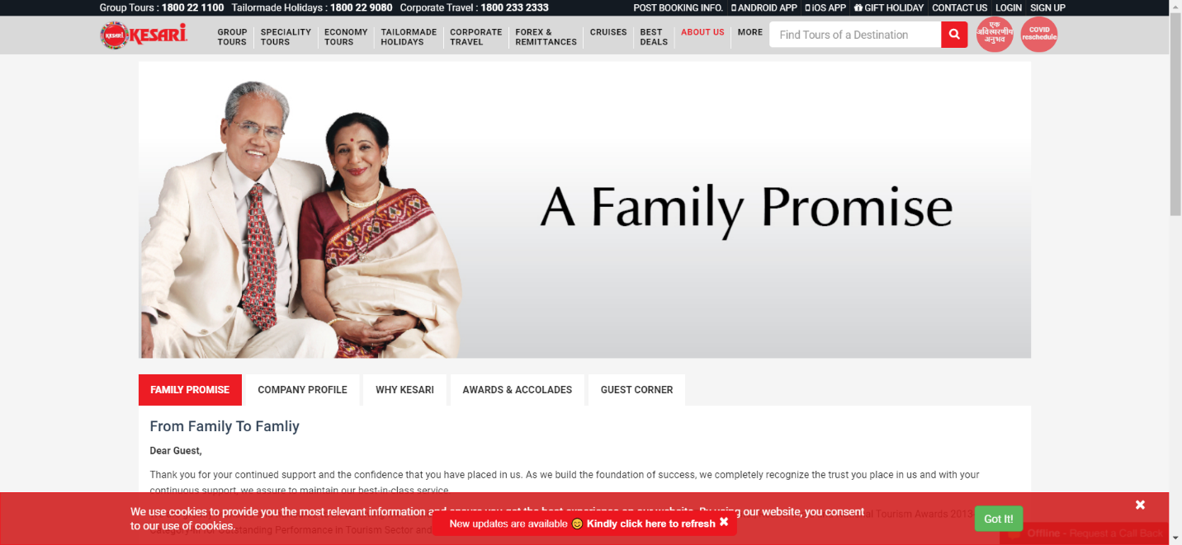

|  |
| --- |
| **TC160:-To check COMPANY PROFILE submodule** |

//company profile

w.findElement(By.*xpath*("//*[@id=\"main\"]/div/div/div/div/ul/li[2]/a")).click();

System.***out***.println("COMPANY PROFILE");

System.***out***.println(w.getCurrentUrl());

Thread.*sleep*(2000);

//successfully checked COMPANY PROFILE submodule

|  |
| --- |
| **TC161:-To check WHY KESARI submodule** |

//why kesari

w.findElement(By.*xpath*("//*[@id=\"main\"]/div/div/div/div/ul/li[3]/a")).click(); System.***out***.println("WHY KESARI");

System.***out***.println(w.getCurrentUrl());

Thread.*sleep*(2000);

//successfully checked WHY KESARI submodule

|  |
| --- |
| **TC162:-To check AWARDS AND ACCOLADES submodule** |

//awards and accolades

w.findElement(By.*xpath*("//*[@id=\"main\"]/div/div/div/div/ul/li[4]/a")).click();

Thread.*sleep*(2000);

System.***out***.println("AWARDS AND ACCOLADES");

Thread.*sleep*(2000);

System.***out***.println(w.getCurrentUrl());

Thread.*sleep*(2000);

//1st 2017 award w.findElement(By.*xpath*("//*[@id=\"awards\"]/div[1]/h4/a")).click();

Thread.*sleep*(2000);

w.findElement(By.*cssSelector*("div.ng-scope:nth-child(3) section.ng-scope:nth-child(2) div.container div.row div.col-xs-12 div.tab-container.nav-tabs-custom div.ng-isolate-scope:nth-child(3) div.tab-content div.tab-pane.ng-scope.active:nth-child(4) div.toggle-container.toggle-container--style-1.ng-scope div.panel:nth-child(3) h4.panel-title > a:nth-child(1)")).click();

Thread.*sleep*(2000);

//successfully checked AWARDS AND ACCOLADES submodule

|  |
| --- |
| **TC163:-To check GUEST CORNER submodule** |

//guest corner

w.findElement(By.*xpath*("//*[@id=\"main\"]/div/div/div/div/ul/li[5]/a")).click(); System.***out***.println("GUEST CORNER");

Thread.*sleep*(2000);

System.***out***.println(w.getCurrentUrl());

Thread.*sleep*(2000);

//successfully checked GUEST CORNER submodule

|  |
| --- |
| **TC164:-Defect found in branches submodule function of contact us module** |

//HYDERABAD

w.findElement(By.*xpath*("//*[@id=\"leftcolumn\"]/a[7]")).click();

w.findElement(By.*cssSelector*("body:nth-child(2) div:nth-child(2) > a.text:nth-child(7)")).click();

w.findElement(By.*linkText*("HYDERABAD")).click();

Thread.*sleep*(3000);

//JAIPUR

w.findElement(By.*xpath*("//*[@id=\"leftcolumn\"]/a[13]")).click();

w.findElement(By.*linkText*("JAIPUR")).click();

w.findElement(By.*cssSelector*("body:nth-child(2) div:nth-child(2) > a.text:nth-child(13)")).click();

Thread.*sleep*(3000);

//KOLKATA

w.findElement(By.*xpath*("//*[@id=\"leftcolumn\"]/a[9]")).click();

w.findElement(By.*linkText*("KOLKATA")).click();

w.findElement(By.*cssSelector*("body:nth-child(2) div:nth-child(2) > a.text:nth-child(9)")).click();

Thread.*sleep*(3000);

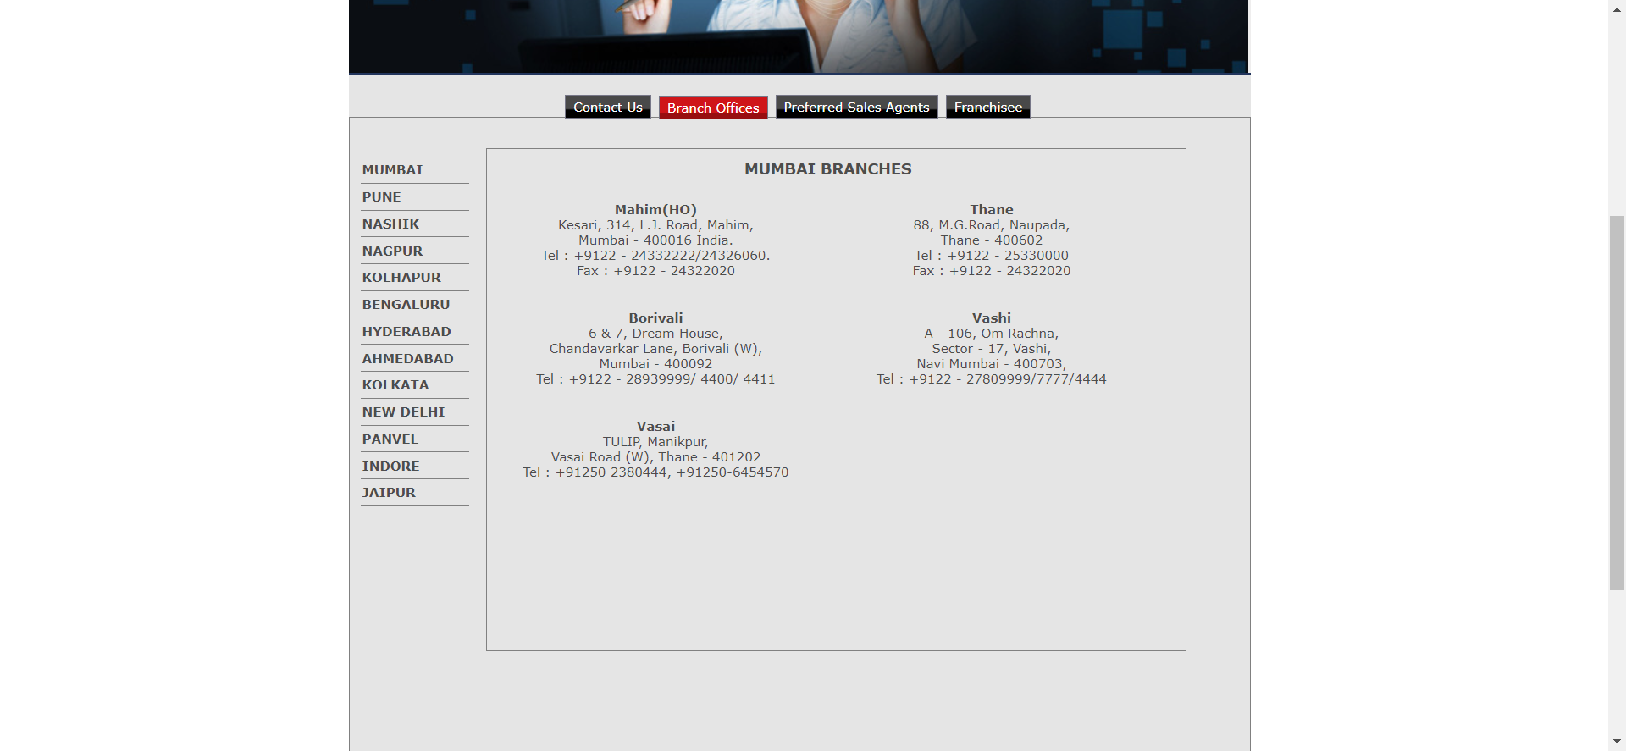

//defect found in this module. Code is not working using any locator

|  |
| --- |
| **TC165:- defect found in preferred sales agents in contact us submodule** |

// Preferred Sales Agents

//Punjab

w.findElement(By.*linkText*("PUNJAB")).click();

w.findElement(By.*cssSelector*("body:nth-child(2) div:nth-child(2) > a.text:nth-child(13)")).click();

w.findElement(By.*xpath*("//*[@id=\"leftcolumn\"]/a[13]")).click();

Thread.*sleep*(1000);

//Aasam

w.findElement(By.*linkText*("ASSAM")).click();

w.findElement(By.*cssSelector*("body:nth-child(2) div:nth-child(2) > a.text:nth-child(2)")).click();

w.findElement(By.*xpath*("//*[@id=\"leftcolumn\"]/a[2]")).click();

Thread.*sleep*(2000);

// defect is here .Code is not working here using any locator

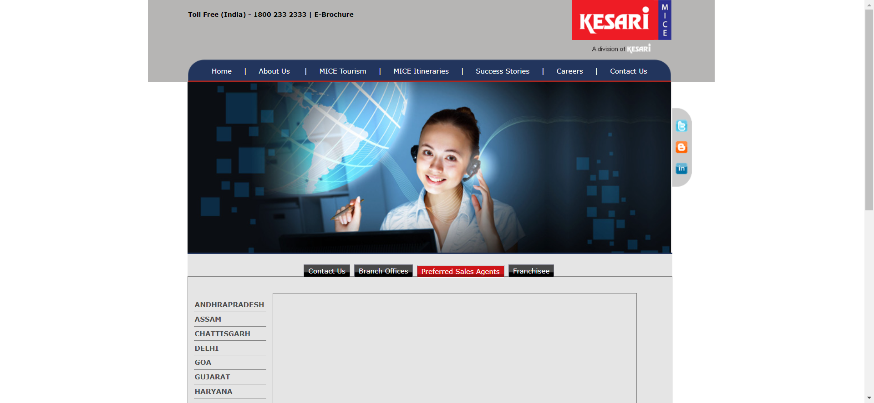

|  |
| --- |
| **TC166:defect found in FAQ corporate travel module** |

//Frequently Asked Questions

//3

w.findElement(By.*cssSelector*("div.ng-scope:nth-child(3) section.ng-scope:nth-child(2) div.container div.forex-remittance-box:nth-child(6) div.row div.col-xs-12 div.box-white.shadow div.toggle-container.toggle-container--style-1 div.panel:nth-child(3) h4.panel-title > a.collapsed")).click();

w.findElement(By.*xpath*("//*[@id=\"content\"]/div/div[6]/div/div/div/div/div[3]/h4/a")).click();

Thread.*sleep*(2000);

//7

w.findElement(By.*xpath*("//*[@id=\"content\"]/div/div[6]/div/div/div/div/div[7]/h4/a")).click();

Thread.*sleep*(2000);

w.findElement(By.*xpath*("//*[@id=\"content\"]/div/div[6]/div/div/div/div/div[7]/h4/a")).click();

Thread.*sleep*(2000);

//defect is found here. Code is not working/ run here

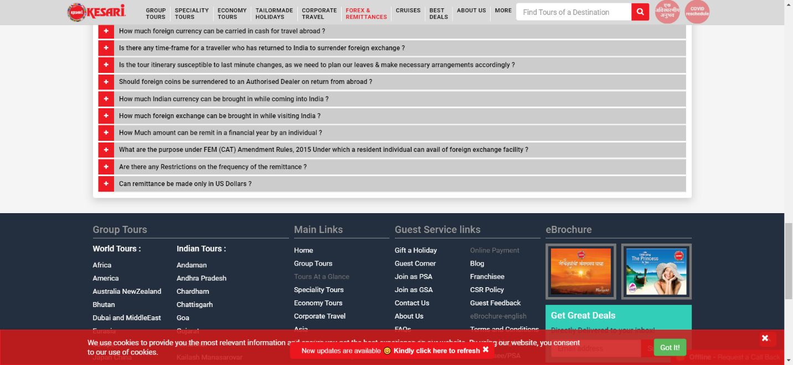

|  |
| --- |
| **TC167:-defect in highlight** |

//highlight

//w.findElement(By.linkText("Highlight")).click(); w.findElement(By.*xpath*("//*[@id=\"main\"]/div[3]/div[1]/div[2]/div/div[1]/ul/li[2]/a")).click();

Thread.*sleep*(2000);

// w.findElement(By.cssSelector("div.ng-scope:nth-child(3) section.ng-scope:nth-child(3) div.container div.row:nth-child(3) div.col-md-9.col-xs-12 div.row div.col-xs-12 div.tab-container:nth-child(1) ul.nav.nav-tabs.nav-tabs-style-1 li.ng-scope:nth-child(2) > a:nth-child(1)")).click();

|  |
| --- |
| **TC168:-Defect found that Elements are unable to intercepted in DUBAI AND MIDDLEEAST submodule.** |

w.findElement(By.xpath("//input[@id='startDatePicker']")).click();

Thread.sleep(3000);

w.findElement(By.cssSelector("#datepicker-3487-6058-18 > button > span")).click();

Thread.sleep(2000);

w.findElement(By.xpath("//input[@id='endDatePicker']")).click();

Thread.sleep(2000);

w.findElement(By.xpath("//*[@id=\"datepicker-3487-6058-24\"]/button")).click();

Thread.sleep(5000);

w.findElement(By.xpath("//body/div[3]/section[1]/div[1]/div[1]/div[3]/div[1]/v-accordion[1]/v-pane[8]/v-pane-content[1]/div[1]/div[1]/form[1]/div[1]/div[3]/div[1]/div[1]/span[1]/i[1]")).click();

w.findElement(By.xpath("//span[contains(text(),'June')]")).click();

w.findElement(By.xpath("//body/div[3]/section[1]/div[1]/div[1]/div[3]/div[1]/v-accordion[1]/v-pane[8]/v-pane-content[1]/div[1]/div[1]/form[1]/div[1]/div[4]/div[1]/button[1]")).click();

System.out.println("Your Tour Package are Coming Soon.....");

Thread.sleep(3000);

|  |
| --- |
| **TC169:-Defect found that Elements are unable to intercepted in SHRI LANKA AND MALDIVES submodules.** |

w.findElement(By.xpath("//input[@id='startDatePicker']")).click();

w.findElement(By.cssSelector("#datepicker-4461-3623-10 > button")).click();

w.findElement(By.xpath("//input[@id='endDatePicker']")).click();

w.findElement(By.xpath("//*[@id=\"datepicker-2515-8017-24\"]/button")).click();

Thread.sleep(4000);

w.findElement(By.xpath("//body/div[3]/section[1]/div[1]/div[1]/div[3]/div[1]/v-accordion[1]/v-pane[8]/v-pane-content[1]/div[1]/div[1]/form[1]/div[1]/div[3]/div[1]/div[1]/span[1]/i[1]")).click();

w.findElement(By.xpath("//span[contains(text(),'June')]")).click();

w.findElement(By.xpath("//body/div[3]/section[1]/div[1]/div[1]/div[3]/div[1]/v-accordion[1]/v-pane[8]/v-pane-content[1]/div[1]/div[1]/form[1]/div[1]/div[4]/div[1]/button[1]")).click();

System.out.println("Your Tour Package of ShriLanka And Maldive is Coming Soon.....");

|  |
| --- |
| **TC170:-Defect found that Elements are unable to intercepted in ANDRA PRADESH hydrabad Ramoji (Highlights) submodules.** |

// w.findElement(By.partialLinkText("Email this itinera")).click();

//w.findElement(By.xpath("//body/div[9]/div[1]/div[1]/div[1]/form[1]/div[1]/div[1]/input[1]")).sendKeys("komal123@gmail.com");

// w.findElement(By.xpath("//button[contains(text(),'Send')]")).click();

//w.findElement(By.partialLinkText("Hyderab")).click();

|  |
| --- |
| **TC171:-Defect found that Elements are unable to intercepted in ANDRA PRADESH hydrabad Ramoji (Enquiry) submodules.** |

w.findElement(By.xpath("//*[@id=\"main\"]/div[3]/div[2]/div[2]/div[1]/article/figure/div[7]/div[2]/a[3]")).sendKeys("Komal");

w.findElement(By.xpath("//body/div[9]/div[1]/div[1]/div[1]/div[2]/form[1]/div[2]/div[1]/input[1]")).sendKeys("alibag");

w.findElement(By.xpath("//body/div[9]/div[1]/div[1]/div[1]/div[2]/form[1]/div[3]/div[1]/input[1]")).sendKeys("7");

w.findElement(By.xpath("//body/div[9]/div[1]/div[1]/div[1]/div[2]/form[1]/div[4]/div[1]/input[1]")).sendKeys("komal@gmail.com");

w.findElement(By.xpath("//body/div[9]/div[1]/div[1]/div[1]/div[2]/form[1]/div[5]/div[1]/input[1]")).sendKeys("8765432789");

w.findElement(By.xpath("//body/div[9]/div[1]/div[1]/div[1]/div[2]/form[1]/div[6]/div[1]/input[1]")).click();

w.findElement(By.xpath("//span[contains(text(),'31')]")).click();

w.findElement(By.xpath("//body/div[9]/div[1]/div[1]/div[1]/div[2]/form[1]/div[7]/textarea[1]")).sendKeys("not Required....");

w.findElement(By.xpath("//body/div[9]/div[1]/div[1]/div[1]/div[1]/button[1]")).click();

Thread.sleep(5000);